# Transcriptome-Based Prediction of Methylphenidate Efficacy: Implications for Precision Medicine in Psychiatric Disorders

# Exploring the Genetic Landscape of Methylphenidate Response: Insights into Treatment Optimization

Muhammad Elsadany1,2, Taylor R. Thomas1,2, Lucas G. Casten1,2, Jacob J. Michaelson1,2,3,4,5 *

**1** Department of Psychiatry, University of Iowa, Iowa City, IA

**2** Interdisciplinary Graduate Program in Genetics, University of Iowa, Iowa City, IA

**3** Department of Communication Sciences & Disorders, University of Iowa, Iowa City, IA

**4** Iowa Neuroscience Institute, University of Iowa, Iowa City, IA

**5** Department of Biomedical Engineering, University of Iowa, Iowa City, IA

**\*** jacob-michaelson@uiowa.edu

# 1. Abstract

**Background:** The variability in drug response among individuals with neurodevelopmental disorders, such as attention deficit hyperactivity disorder (ADHD), poses a significant challenge for effective pharmacological management. This study aimed to develop a novel method for predicting methylphenidate (MPH) response using genetic profiles and transcriptomic imputation and validate its predictive capacity using data from the SPARK and ABCD cohorts.

**Methods:** We conducted a comprehensive analysis using data from the SPARK and ABCD cohorts. Polygenic scores (PGS) for cognitive traits and ADHD were calculated, and their correlation with medication history was examined. Additionally, a multi-step pipeline was employed, involving the imputation of transcriptomic profiles for excitatory neurons using eQTL weights and comparison to the MPH transcriptomic signature derived from the Connectivity Map (CMap) database. The predicted drug response was then validated against objective measures of attention and cognitive performance.

**Results:** We found a significant correlation between ADHD PGS and the use of stimulant medications (methylphenidate and amphetamines). Interestingly, cognitive PGS showed associations with medication use and choice. Methylphenidate effectiveness correlated positively with communication abilities and negatively with cognitive impairment. The correlation analyses between PGS and methylphenidate response revealed a positive association with specific cognitive traits, suggesting a genetic basis underlying the drug's effectiveness. Our transcriptome imputation-based method successfully predicted methylphenidate response, and the correlation analysis demonstrated a link between genetic cognitive factors and drug effectiveness.

**Conclusion:** This study presents a novel method for predicting MPH response using genetic profiles and transcriptomic imputation. By incorporating objective measures and leveraging genetic information, this approach offers a promising avenue for personalized treatment strategies in neurodevelopmental disorders. The findings contribute to a deeper understanding of the genetic underpinnings of drug response and lay the foundation for optimizing medication choices and dosages to enhance treatment outcomes.

**Keywords:** ADHD, methylphenidate response, genetic profiles, transcriptomic imputation, polygenic scores, personalized medicine.

# 2. Introduction

Although progress in human genetics has drastically accelerated in the decades since the Human Genome Project, the current impact of genomic data on treatments for disease is limited. Still, individual genotype profiles have been known to be a major player in differentiating response to different pharmacological compounds (Dunnenberger et al., 2015; Relling & Evans, 2015). The field of pharmacogenomics is rapidly growing, with the aim of providing personalized interventions for patients by uncovering the genetic basis of inter-individual variability in drug response. However, currently available pharmacogenomic services are limited in their ascertainment of genetic variation, with an emphasis on drug metabolism, known drug targets, and known mechanisms of action. This approach may result in blind spots relating to off-target effects and additional/alternative therapeutic mechanisms. A more comprehensive understanding of drug response could provide recommendations that maximize therapeutic effect while minimizing side effects.

Attention deficit hyperactivity disorder (ADHD) is a prevalent condition, affecting approximately 6 million (9.8%) of US children aged 3–17 years ever diagnosed with ADHD (using CDC data from 2016-2019), with significant variations across different populations and cultures (CDC, 2022). The etiology of ADHD is complex, involving a combination of genetic, environmental, and neurobiological factors, and its diagnosis often occurs alongside comorbid conditions such as oppositional defiant disorder (ODD), conduct disorder (CD), and learning disabilities (LD) (Pliszka, 1998). While several treatment options are available, methylphenidate (MPH) remains one of the most prescribed medications due to its efficacy in alleviating ADHD symptoms. However, predicting individual response to methylphenidate treatment poses a challenge, necessitating a comprehensive exploration of various factors that influence treatment outcomes. This paper provides an updated view of ADHD treatment, specifically using MPH, in children, its comorbidities, and contemporary perspectives on predicting response to MPH, integrating relevant research and current statistics.

Individuals with ADHD often require pharmacological interventions to manage their symptoms and improve their daily functioning (American-Academy-of-Pediatrics, 2022). Methylphenidate (MPH), a commonly prescribed medication for ADHD, has shown efficacy in enhancing attention and reducing hyperactivity in many individuals (Storebo et al., 2018). However, there is significant variability in individual drug response, with some individuals experiencing substantial benefits while others show limited improvement or even adverse effects (Cortese et al., 2018; de Faria et al., 2022; Kimko et al., 1999). Understanding the factors that contribute to this variability in drug response is crucial for optimizing treatment strategies and achieving personalized medicine approaches.

Traditionally, drug response assessments have relied on subjective reporting from patients, parents, or caregivers (Chang et al., 2021; Grazioli et al., 2021; Vertessen et al., 2023). Although valuable, these assessments are inherently subjective and can be influenced by various factors, including placebo effects and biases. Objective measures, such as neuroimaging or behavioral tasks, have also been employed to evaluate drug effectiveness. However, these measures often require the patient to be on medication for several weeks before any measurable changes can be observed, making them time-consuming and less suitable for rapid treatment optimization.

To address these limitations, there is a growing interest in leveraging genetic information to predict drug response. Genetic factors play a significant role in individual variability in drug metabolism, receptor binding, and overall pharmacodynamics (Belle & Singh, 2008; Evans & Johnson, 2001; Ingelman-Sundberg et al., 2018; Roden et al., 2011; Scharfe et al., 2017; Weinshilboum, 2003; Wilke & Dolan, 2011). Polygenic scores (PGS) derived from genome-wide association studies (GWAS) have been used to capture the genetic contribution to complex traits and diseases. By incorporating PGS into predictive models, it is possible to estimate an individual's likelihood of responding favorably to a specific medication.

In this study, we aimed to develop a method for predicting drug response based on genetic profiles and apply it to methylphenidate. We hypothesized that by leveraging genetic information and transcriptomic profiles, we could identify individuals who are more likely to respond positively to methylphenidate, thereby enabling personalized treatment strategies. Our approach involved imputing transcriptomic profiles for excitatory neurons based on expression quantitative trait loci (eQTL) weights and comparing them to the methylphenidate transcriptomic signature derived from the Connectivity Map (CMap) database.

To study the effectiveness of MPH treatment, we utilized data from the SPARK[1] and ABCD[2] cohorts. The SPARK cohort provided subjective reports on methylphenidate effectiveness and social communication abilities, while the ABCD cohort provided objective measures of attention and cognitive performance. By comparing the computed PGS and our predicted drug response with the objective measures, we aimed to establish the utility of our approach in predicting clinical outcomes and identifying individuals who are more likely to benefit from MPH treatment.

The findings from this study have the potential to significantly impact clinical practice by enabling more targeted and individualized treatment strategies for neurodevelopmental disorders. By accurately predicting drug response, clinicians can optimize medication choices and dosages, reducing the trial-and-error approach and minimizing potential side effects. Moreover, our approach offers a valuable framework for exploring the genetic underpinnings of drug response, contributing to the broader understanding of the pharmacogenetics of neurodevelopmental disorders.

In summary, this study aimed to study and utilize genetic data for predicting methylphenidate response. By incorporating transcriptomic imputation and comparing it to the drug signature, we sought to provide an objective and personalized approach to drug response prediction.

# 3. Results

## 3.1. Correlation between PGS and taking stimulants and other ADHD medications.

In this study, we explored the correlation between polygenic scores (PGS) for cognitive traits and attention-deficit/hyperactivity disorder (ADHD) and the usage of stimulant medications in two independent cohorts, SPARK and ABCD cohorts. For the SPARK cohort (Figure 1-A), we calculated PGS for different cognitive traits and ADHD and then examined its association with participants' medical history. Our analysis revealed a significant positive correlation (FDR < 0.05) between ADHD PGS and the usage of methylphenidate and amphetamines, which are commonly prescribed stimulant medications for ADHD treatment. Similarly, in the ABCD cohort (Figure 1-B), we observed a significant positive correlation between ADHD PGS and the use of various medications, including Adderall, Focalin, Vyvanse, Methylphenidate, Concerta, and Ritalin.

Interestingly, we also found a significant negative correlation between cognitive PGS and the use of certain medications in the ABCD cohort. Specifically, medications such as Adderall, Vyvanse, Clonidine, and Methylphenidate showed a negative association with cognitive PGS. These findings suggest that individuals with higher genetic predisposition for cognitive abilities are less likely to be taking certain medications commonly prescribed for ADHD.

## 3.2. Correlation between MPH Effectiveness and Communication Abilities

We then examined the correlation between reported MPH effectiveness and the social communication abilities of the child as assessed by the Social Communication Questionnaire (SCQ). Our analysis revealed a significant correlation between the effectiveness of MPH and the child's communication abilities (Figure 2-A). Specifically, we found a positive correlation between reported MPH effectiveness and the child's use of verbal communication, including the ability to use phrases. Conversely, we observed a negative correlation between reported MPH effectiveness and behaviors such as odd communication patterns or deliberate self-injury.

## 3.3. Correlation between MPH Effectiveness and Cognitive Impairment

To explore the association between MPH effectiveness and cognitive abilities, we conducted a focused analysis on data from SPARK participants, specifically examining the relationship with cognitive impairment. Using a binary variable indicating the presence or absence of cognitive impairment, we investigated its correlation with reported MPH effectiveness. Our analysis revealed a significant negative correlation between MPH effectiveness and cognitive impairment (Odds Ratio = 0.7213; Fisher's Exact p-value = 0.0034) (Figure 2-B). This finding suggests that individuals with cognitive impairment may experience a lower effectiveness of MPH treatment compared to those without cognitive impairments. It highlights the importance of considering cognitive status when evaluating the therapeutic response to MPH in ADHD individuals, as it may be a critical factor influencing treatment outcomes.

## 3.4. Correlation between MPH effectiveness and PGS in SPARK

To unravel the genetic basis of the observed relationship between MPH effectiveness and cognitive abilities, we computed polygenic scores (PGS) for all participants in SPARK, while controlling for the first five genetic principal components. Subsequently, we investigated the correlation between these PGS and reported MPH effectiveness. Strikingly, we found a positive correlation between the polygenic score for symbol digit matching (source: UKB; see methods) and MPH effectiveness (Spearman correlation coefficient = 0.0512; nominal p-value = 0.0683) (Figure 2-C). This intriguing finding suggests that individuals with higher polygenic scores for symbol digit matching may exhibit a more favorable response to MPH treatment. While we observed similar positive correlations with most other cognitive PGS, none of them reached the threshold of nominal p-value < 0.05.

These results provide promising evidence linking MPH effectiveness to both communication abilities and cognitive functioning. However, further investigation is warranted to validate these findings and explore the underlying mechanisms in larger and more diverse cohorts.

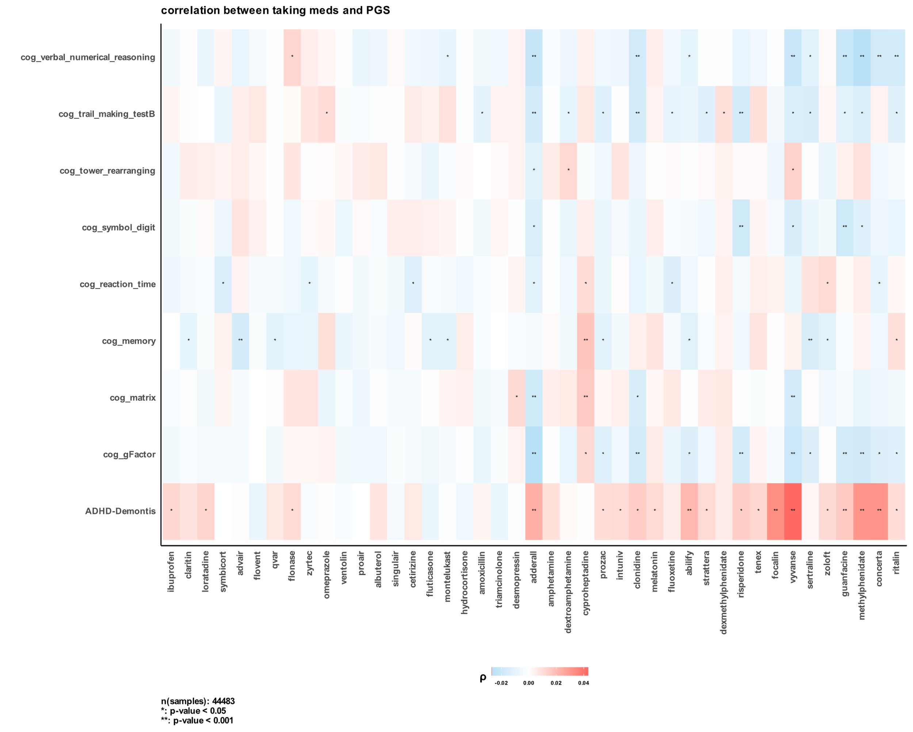

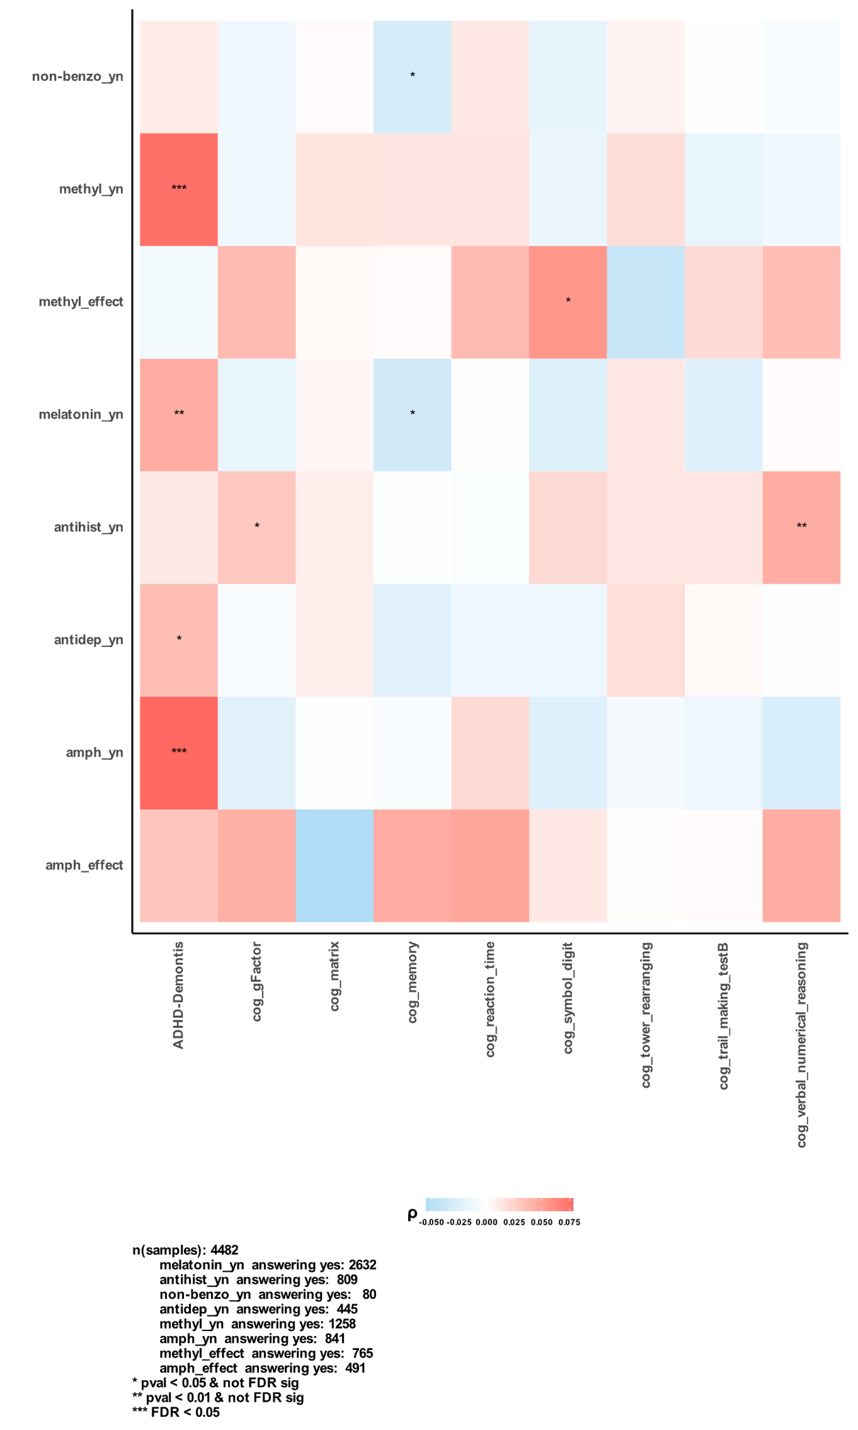

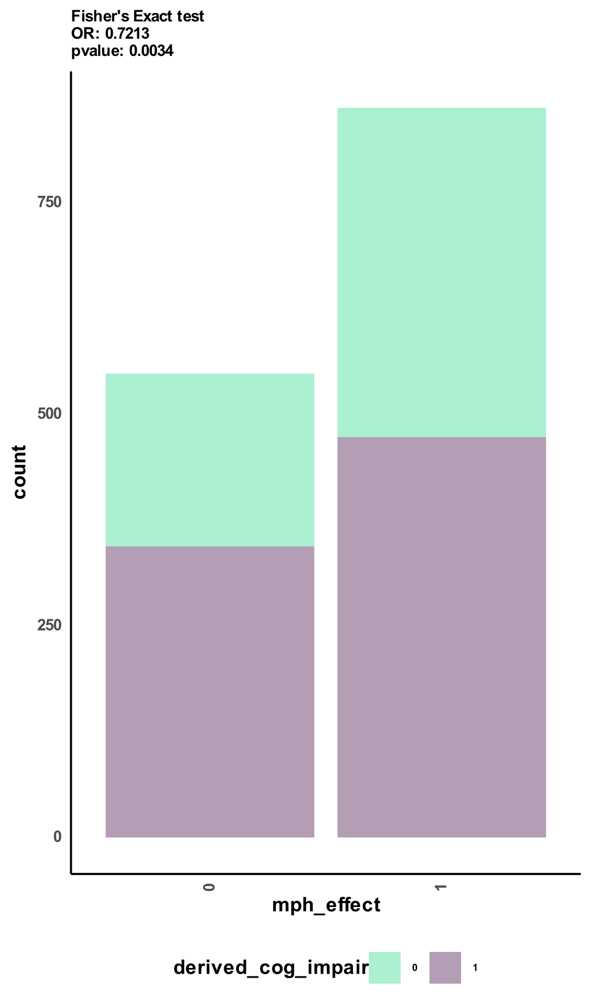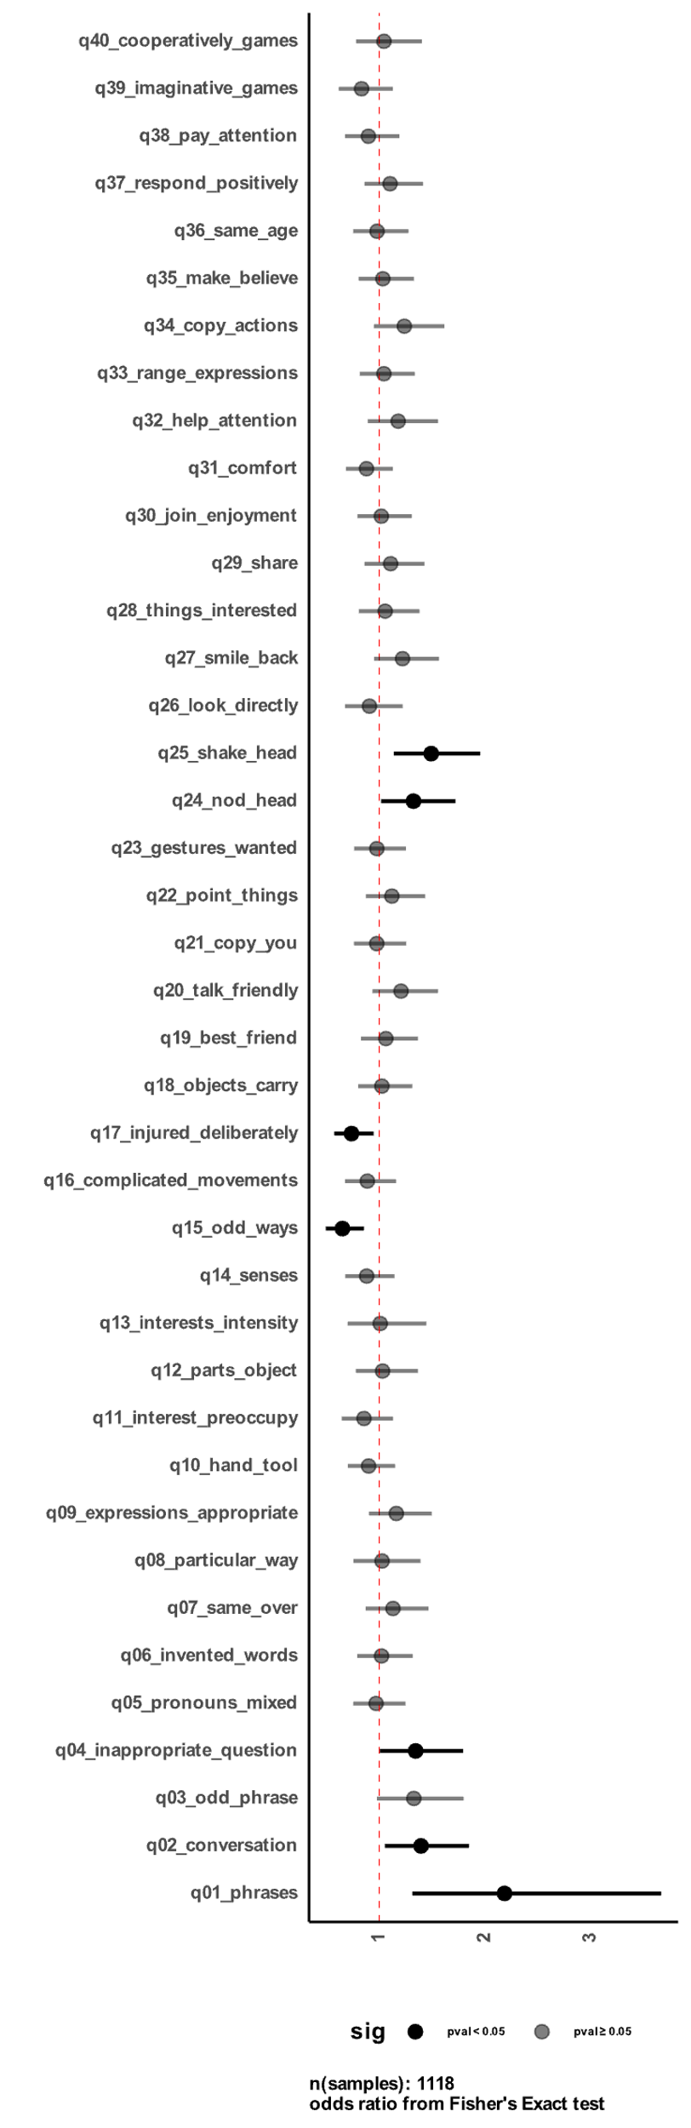

C

B

A

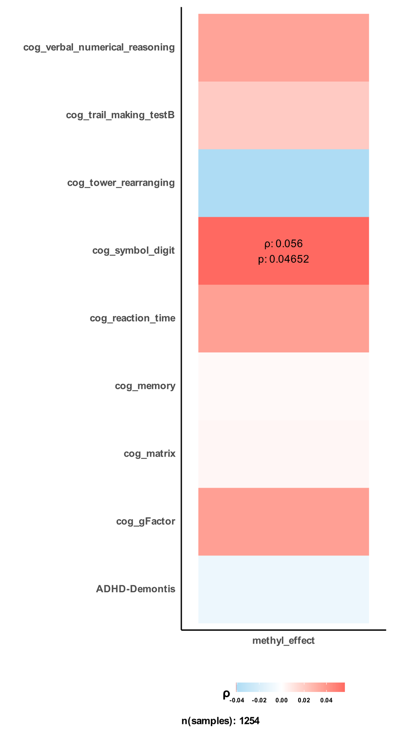

**Figure 1 Correlation between MPH effectiveness and communication abilities, cognitive impairment, and polygenic scores in the SPARK cohort.**  
A) shows odds ratio (OR) between reported methylphenidate effectiveness (MPH_effect) and different social communication questionnaire questions for 1118 samples from SPARK. B) correlation between cognitive impairment labels derived by SPARK and reported methylphenidate effectiveness by parents. C) shows Spearman rank-based correlation coefficients between MPH effectiveness and different calculated polygenic scores (PGS).

## 3.4. Correlation between PGS and MPH effectiveness in the ABCD Cohort

## To validate and extend our findings on the genetic component predicting MPH effectiveness, we conducted a validation analysis using an independent sample from the Adolescent Brain Cognitive Development (ABCD) cohort. In this cohort, we leveraged participants' performance in the first trial run of the stop signal fMRI task (SST) as an objective measure of attention. Additionally, we utilized the child behavior checklist (CBCL) scores reported by parents on their children's behavior.

To investigate how taking MPH affects participants' CBCL and SST performance, we computed the change (delta) for each measure based on the status of taking MPH. For instance, the delta for attention problems from the CBCL of an individual participant was calculated as (attention problems score while being on the drug) – (attention problems score while being off the drug). In this case, a positive delta indicates that the participant had higher attention problems while taking the drug. After computing the deltas for all participants, we assessed their correlation with ADHD and cognitive PGS.

In the analysis of CBCL scores (Figure 3-A), we observed a robust negative correlation between several cognitive polygenic scores and CBCL subscale deltas, indicating that a higher cognitive PGS is associated with a reduction of behavioral symptoms when participants are taking MPH. Although there was a significant positive correlation between ADHD PGS and DSM5 ADHD symptom deltas (participants with high ADHD PGS had higher ADHD DSM5 symptoms when taking MPH), this correlation did not retain statistical significance when correcting CBCL scores for age, sex, and their interaction. (See supplementary for the same correlations with other ADHD medications).

## For the analysis of SST performance (Figure 3-B), we found a highly consistent pattern of a positive correlation between high memory cognitive PGS and better performance (more correct stops) in the SST when participants were taking MPH. However, we did not find any significant correlation between ADHD PGS and participants' performance on the SST while taking MPH.

## These results further strengthen the link between MPH effectiveness and cognitive polygenic scores, particularly memory-related scores. The negative correlation between cognitive PGS and CBCL subscales suggests that individuals with higher cognitive genetic profiles may experience a reduction in behavioral symptoms when taking MPH. Moreover, the positive correlation between memory cognitive PGS and better performance on the SST while taking MPH indicates that individuals with a genetic predisposition for better memory function may respond more positively to the drug. These findings highlight the potential relevance of cognitive genetic factors in shaping the response to MPH treatment and emphasize the importance of considering genetic profiles when optimizing treatment strategies for ADHD.

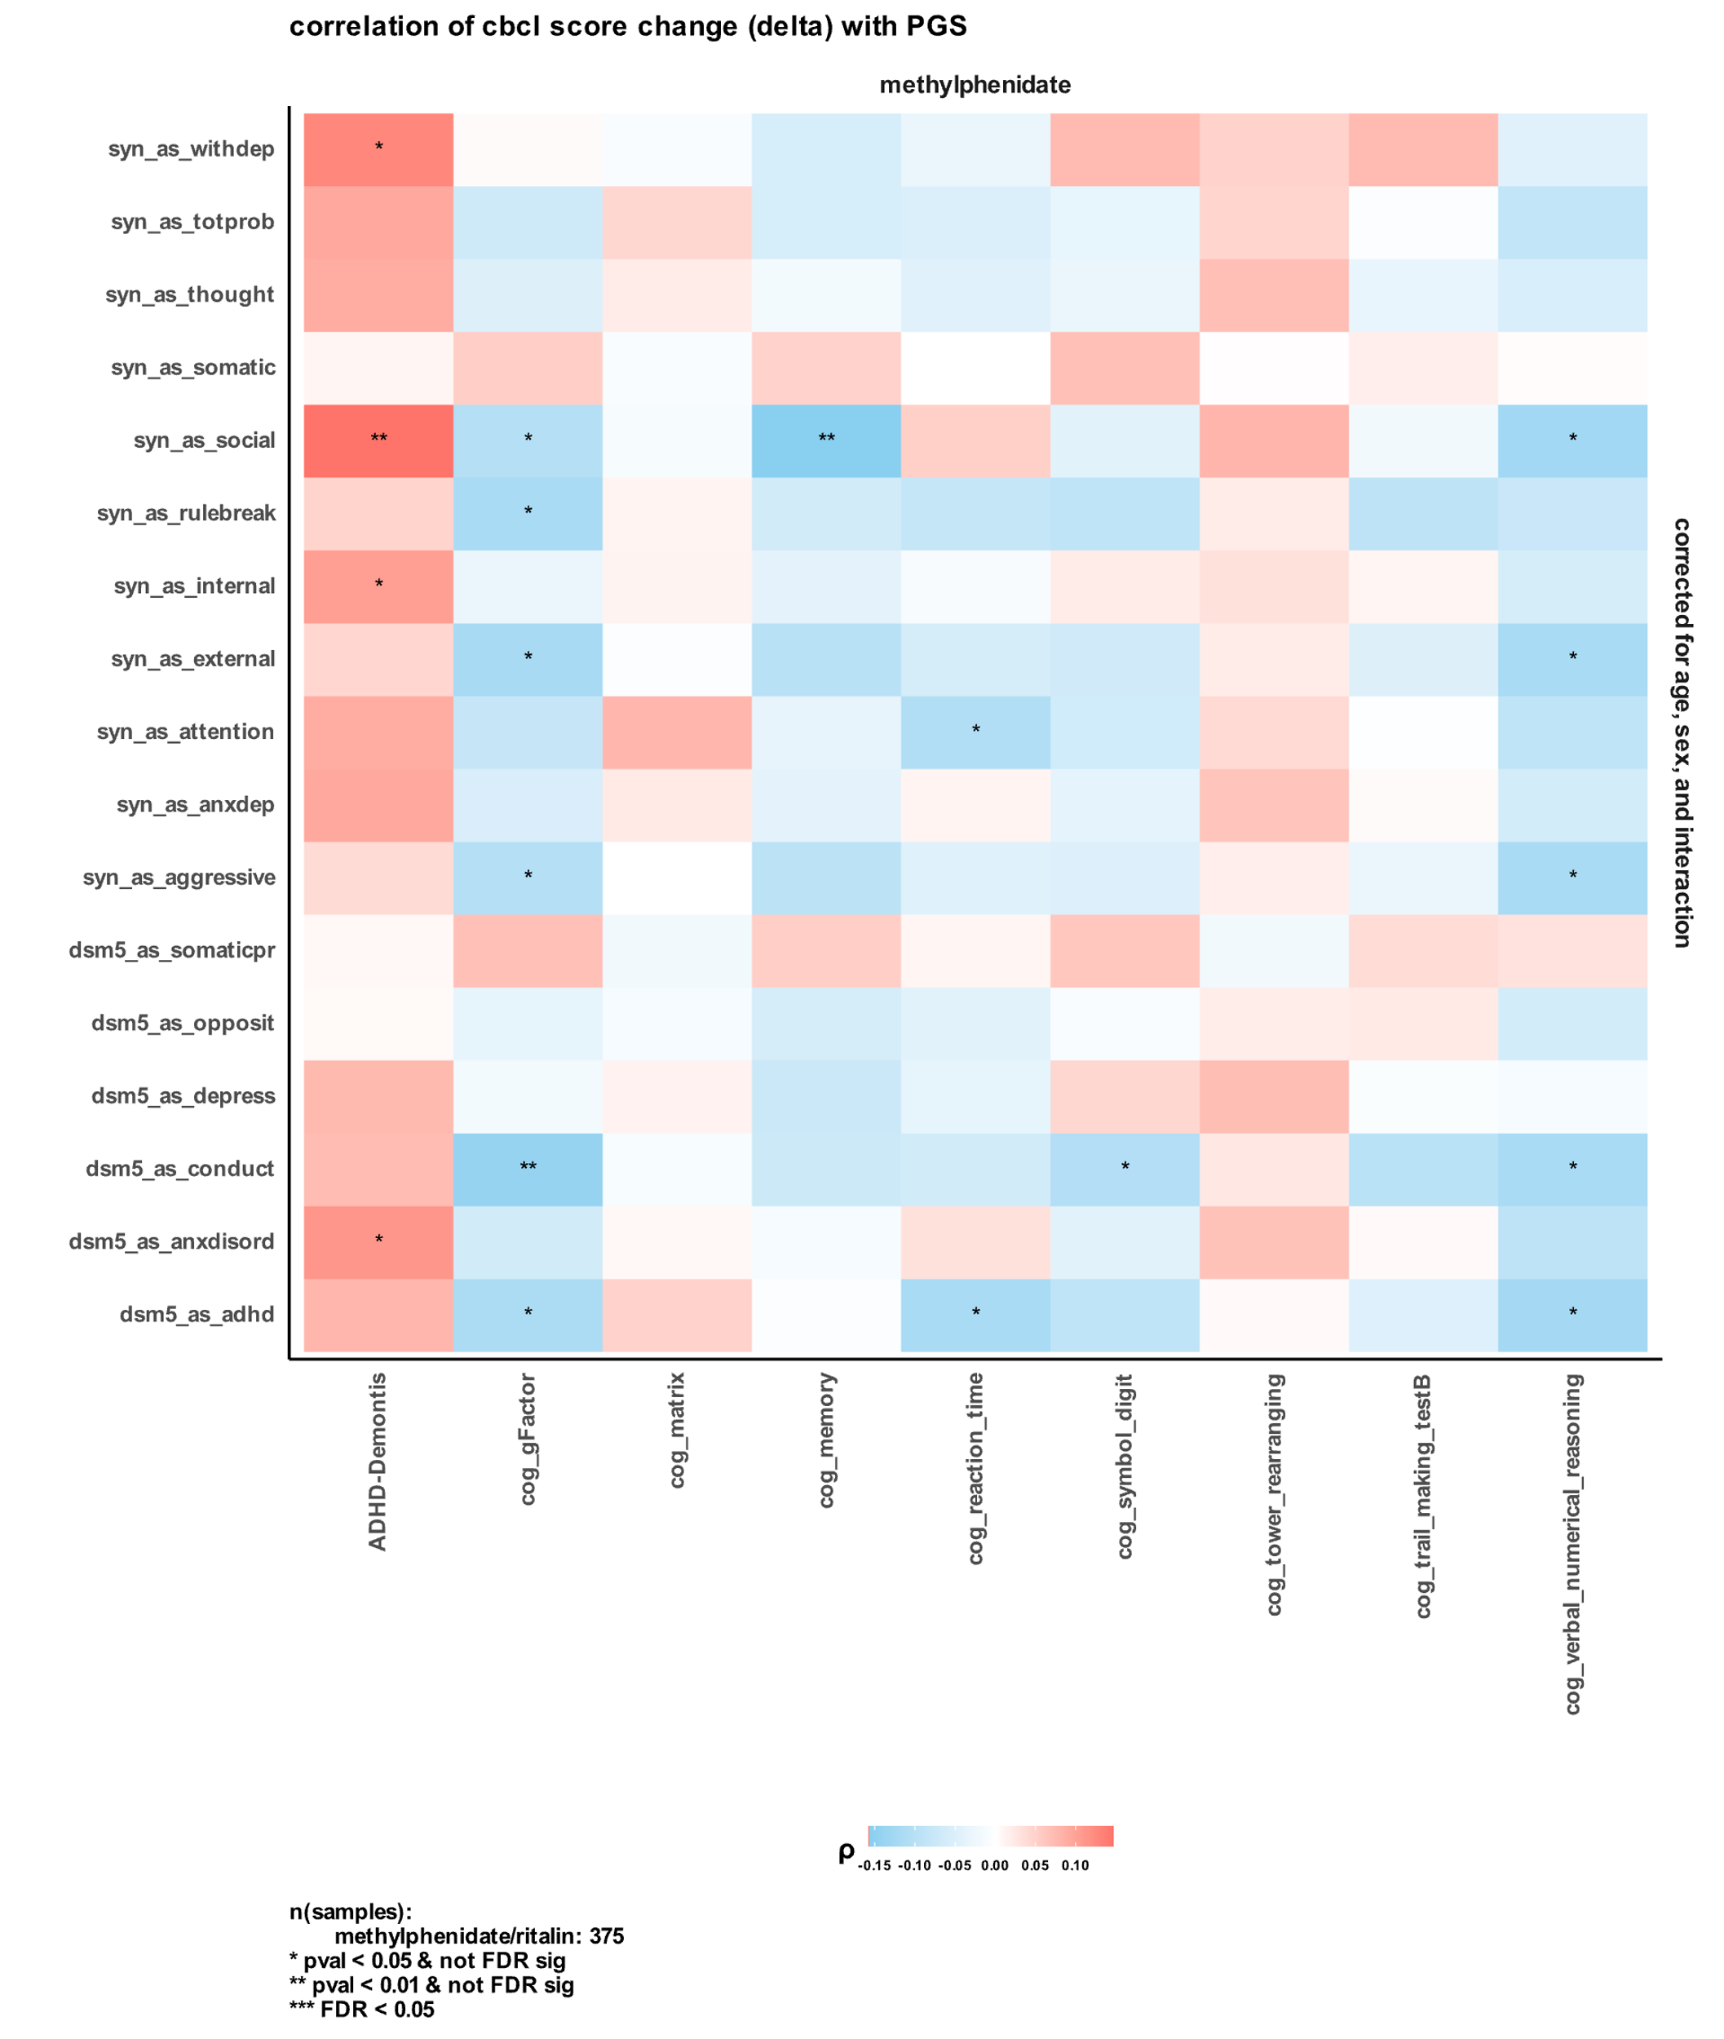

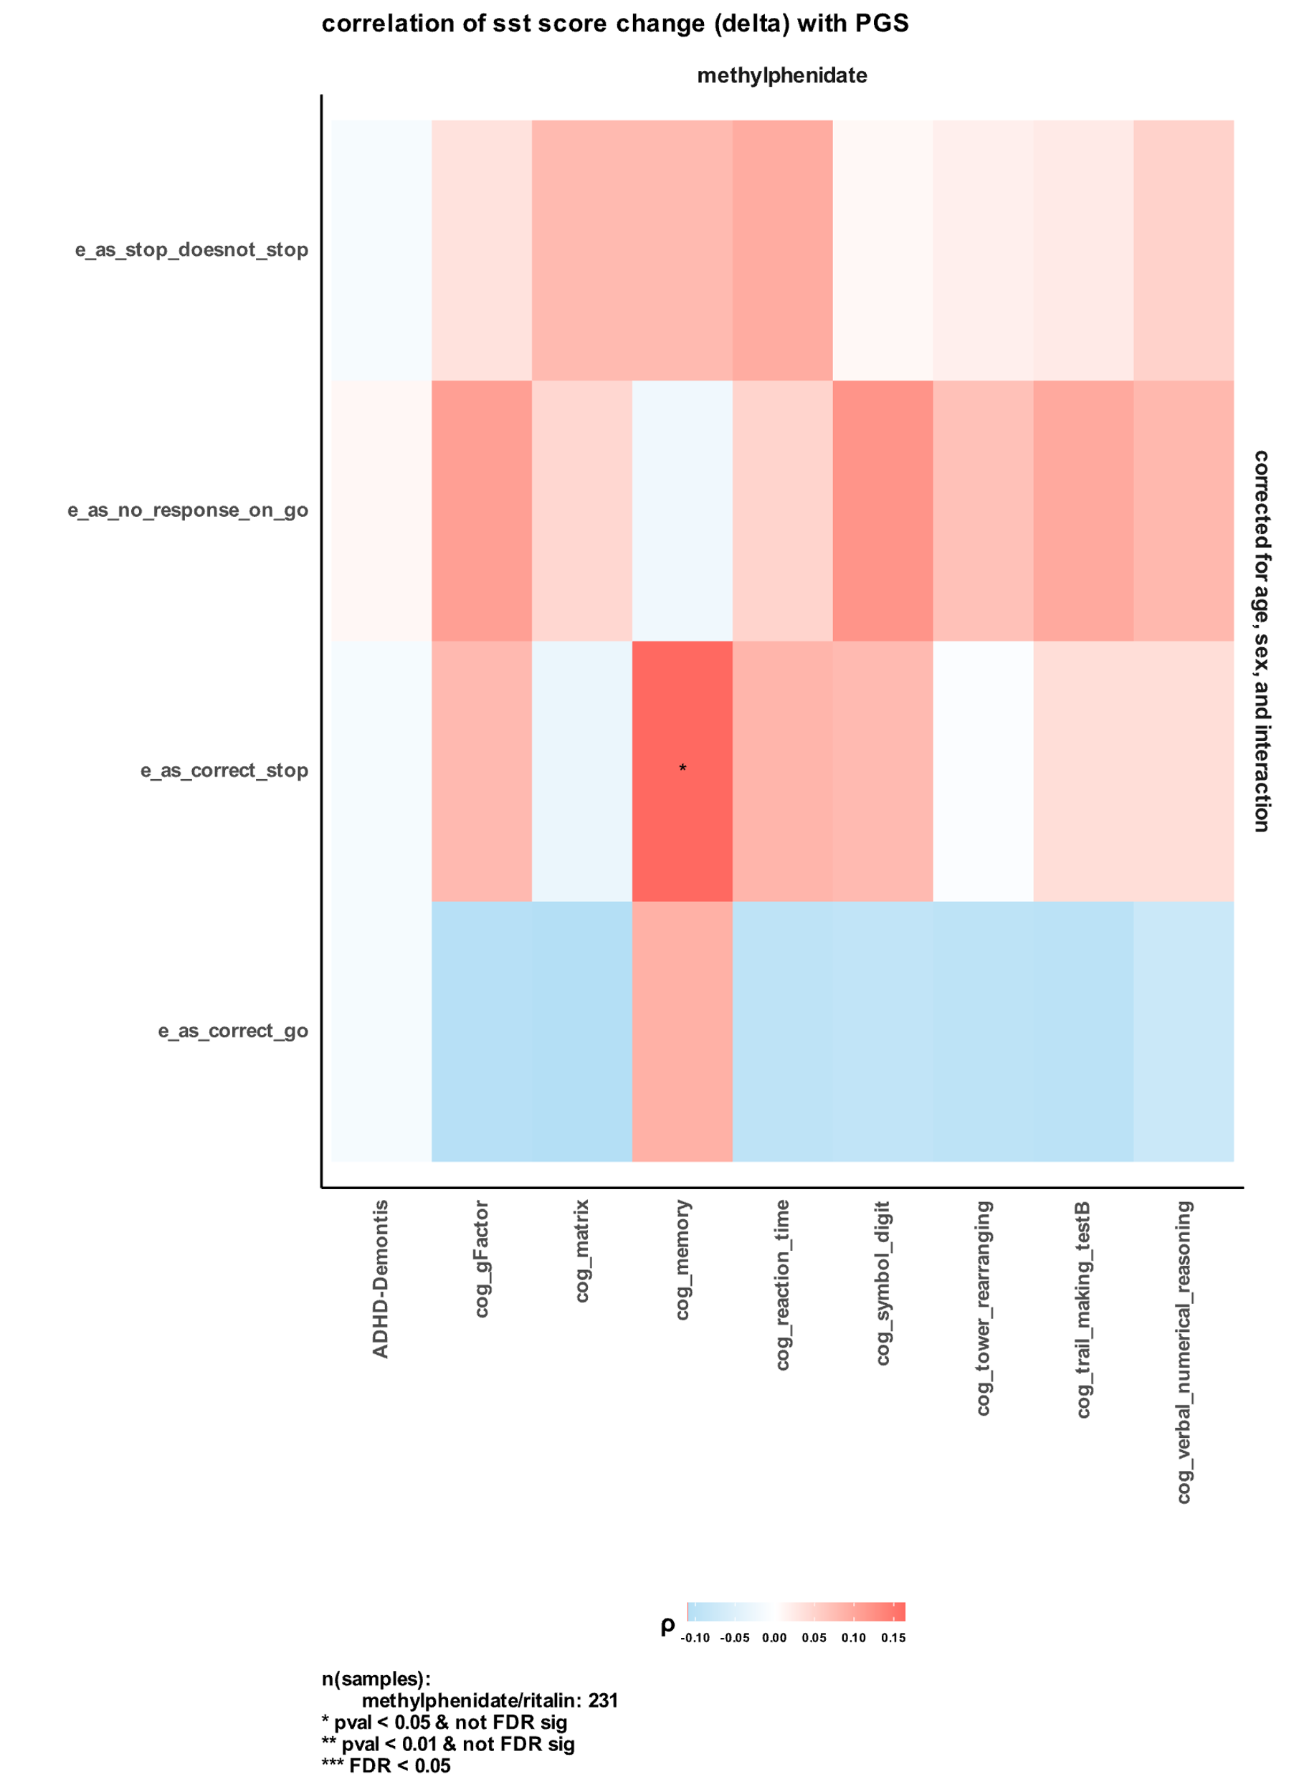

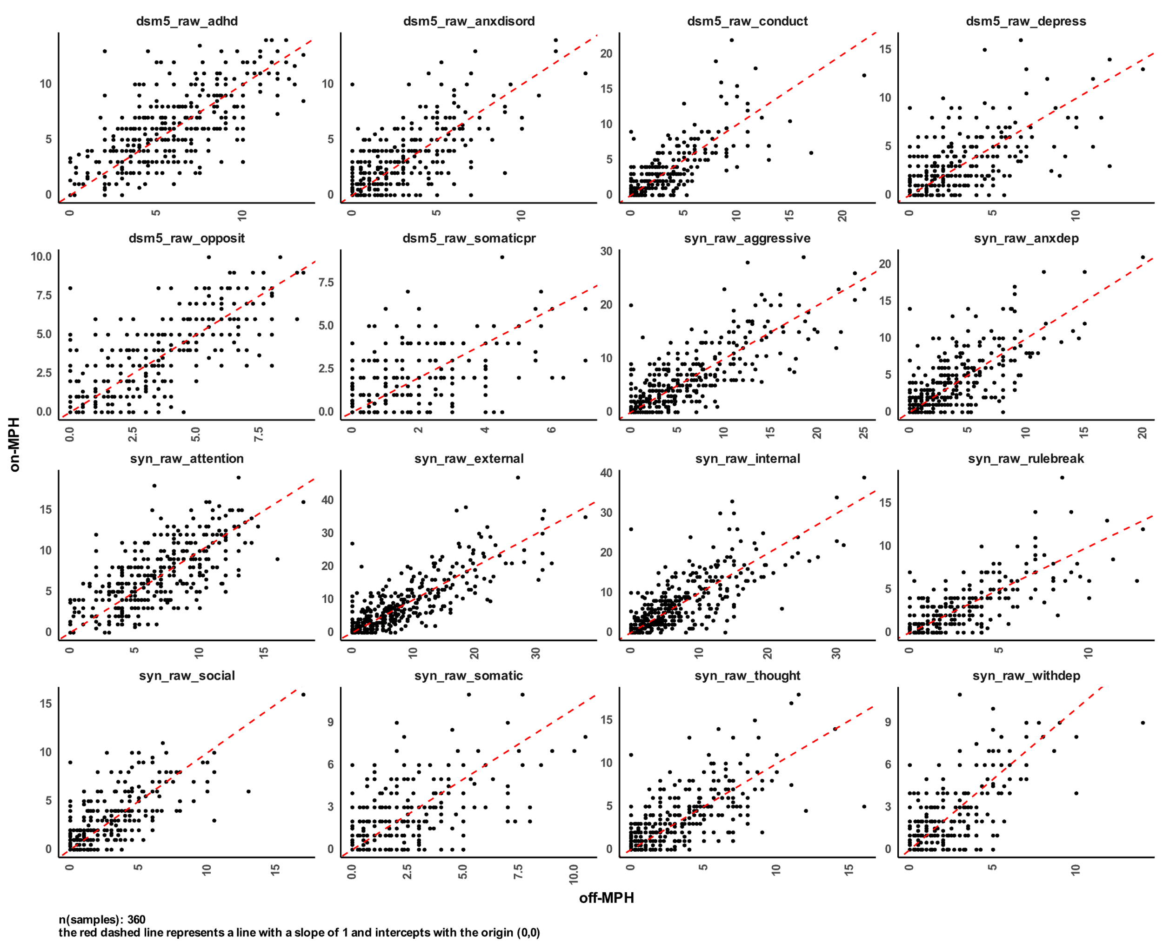

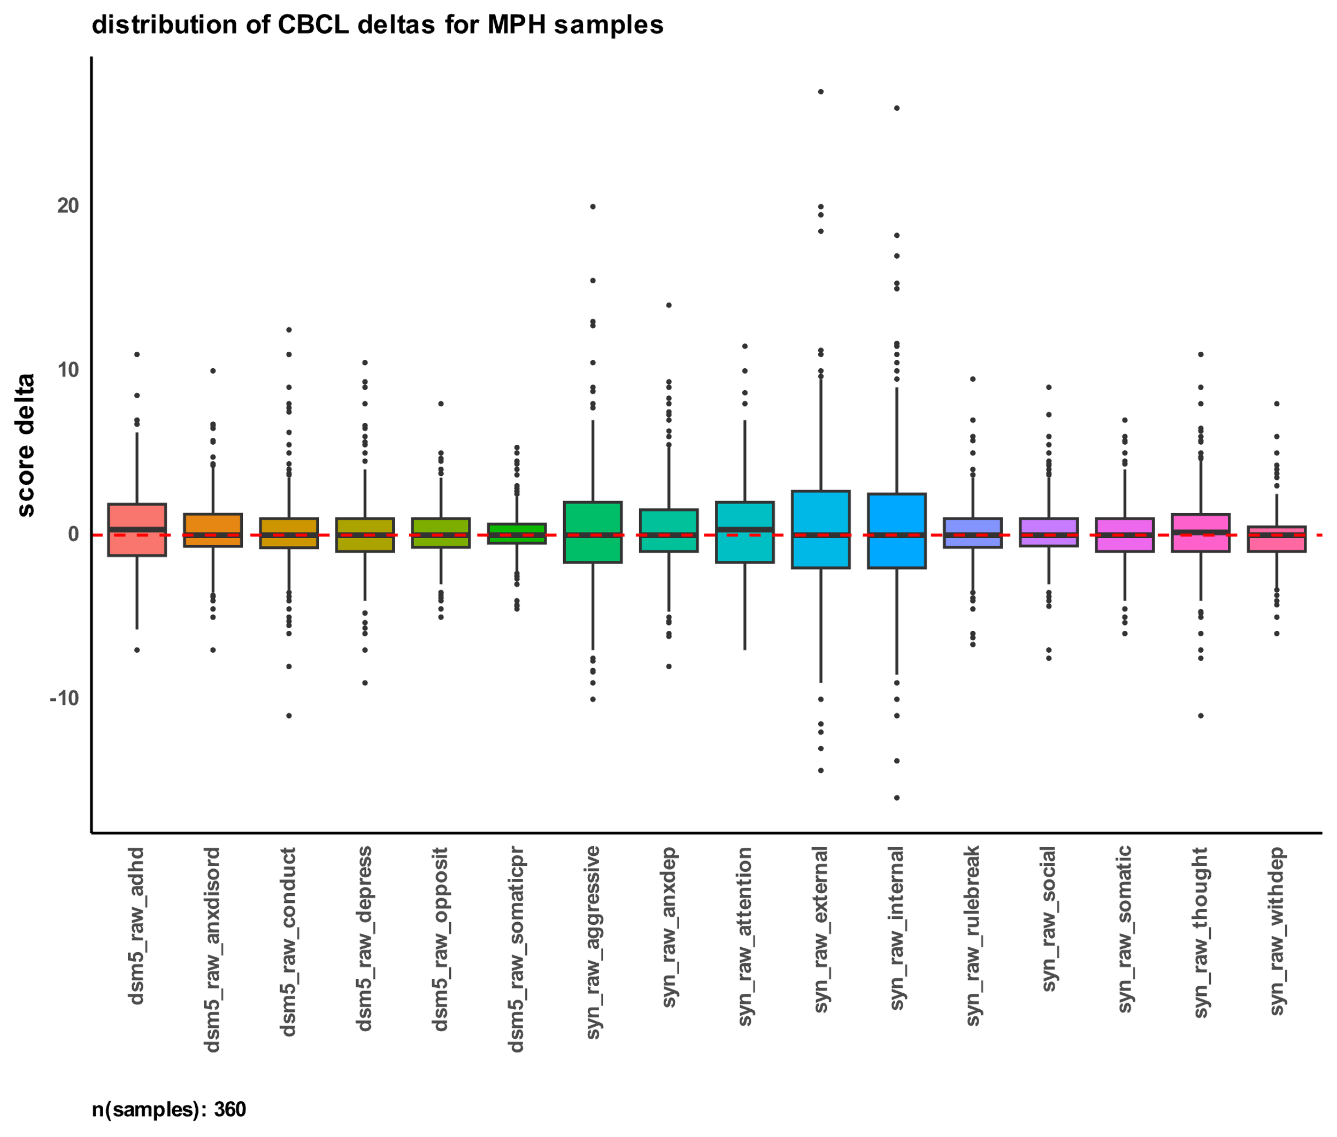

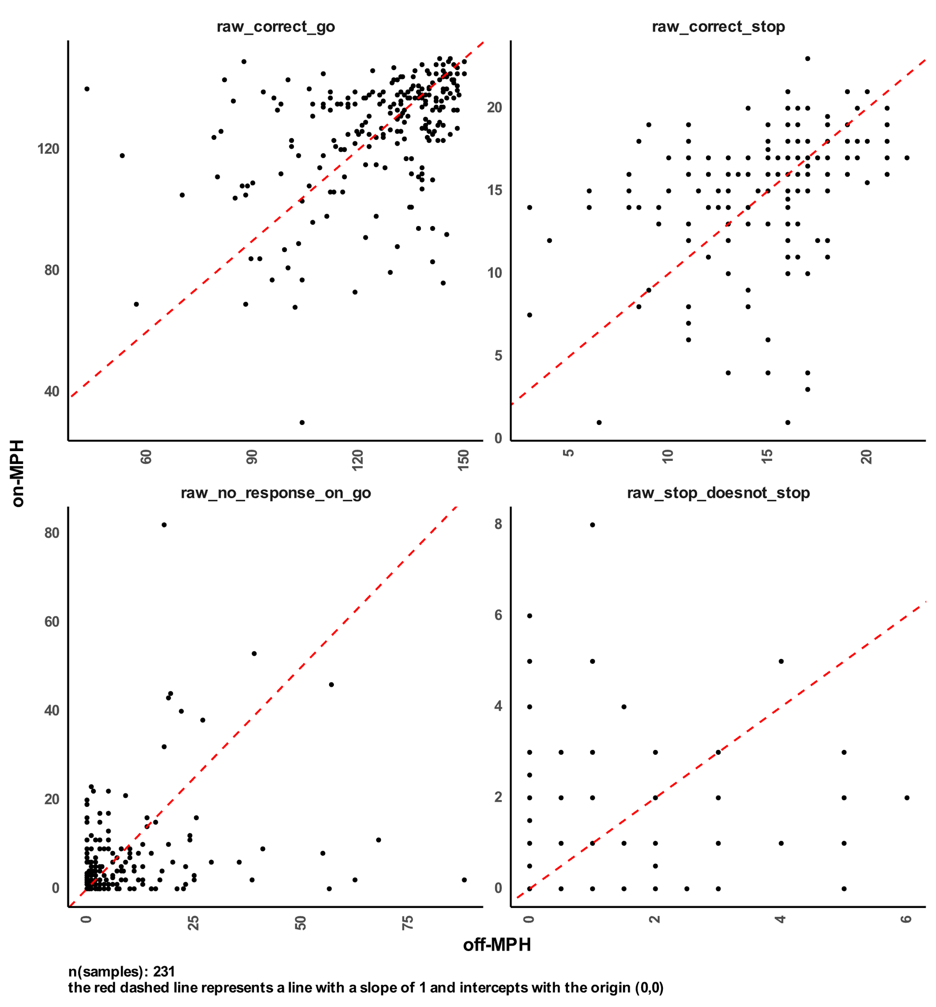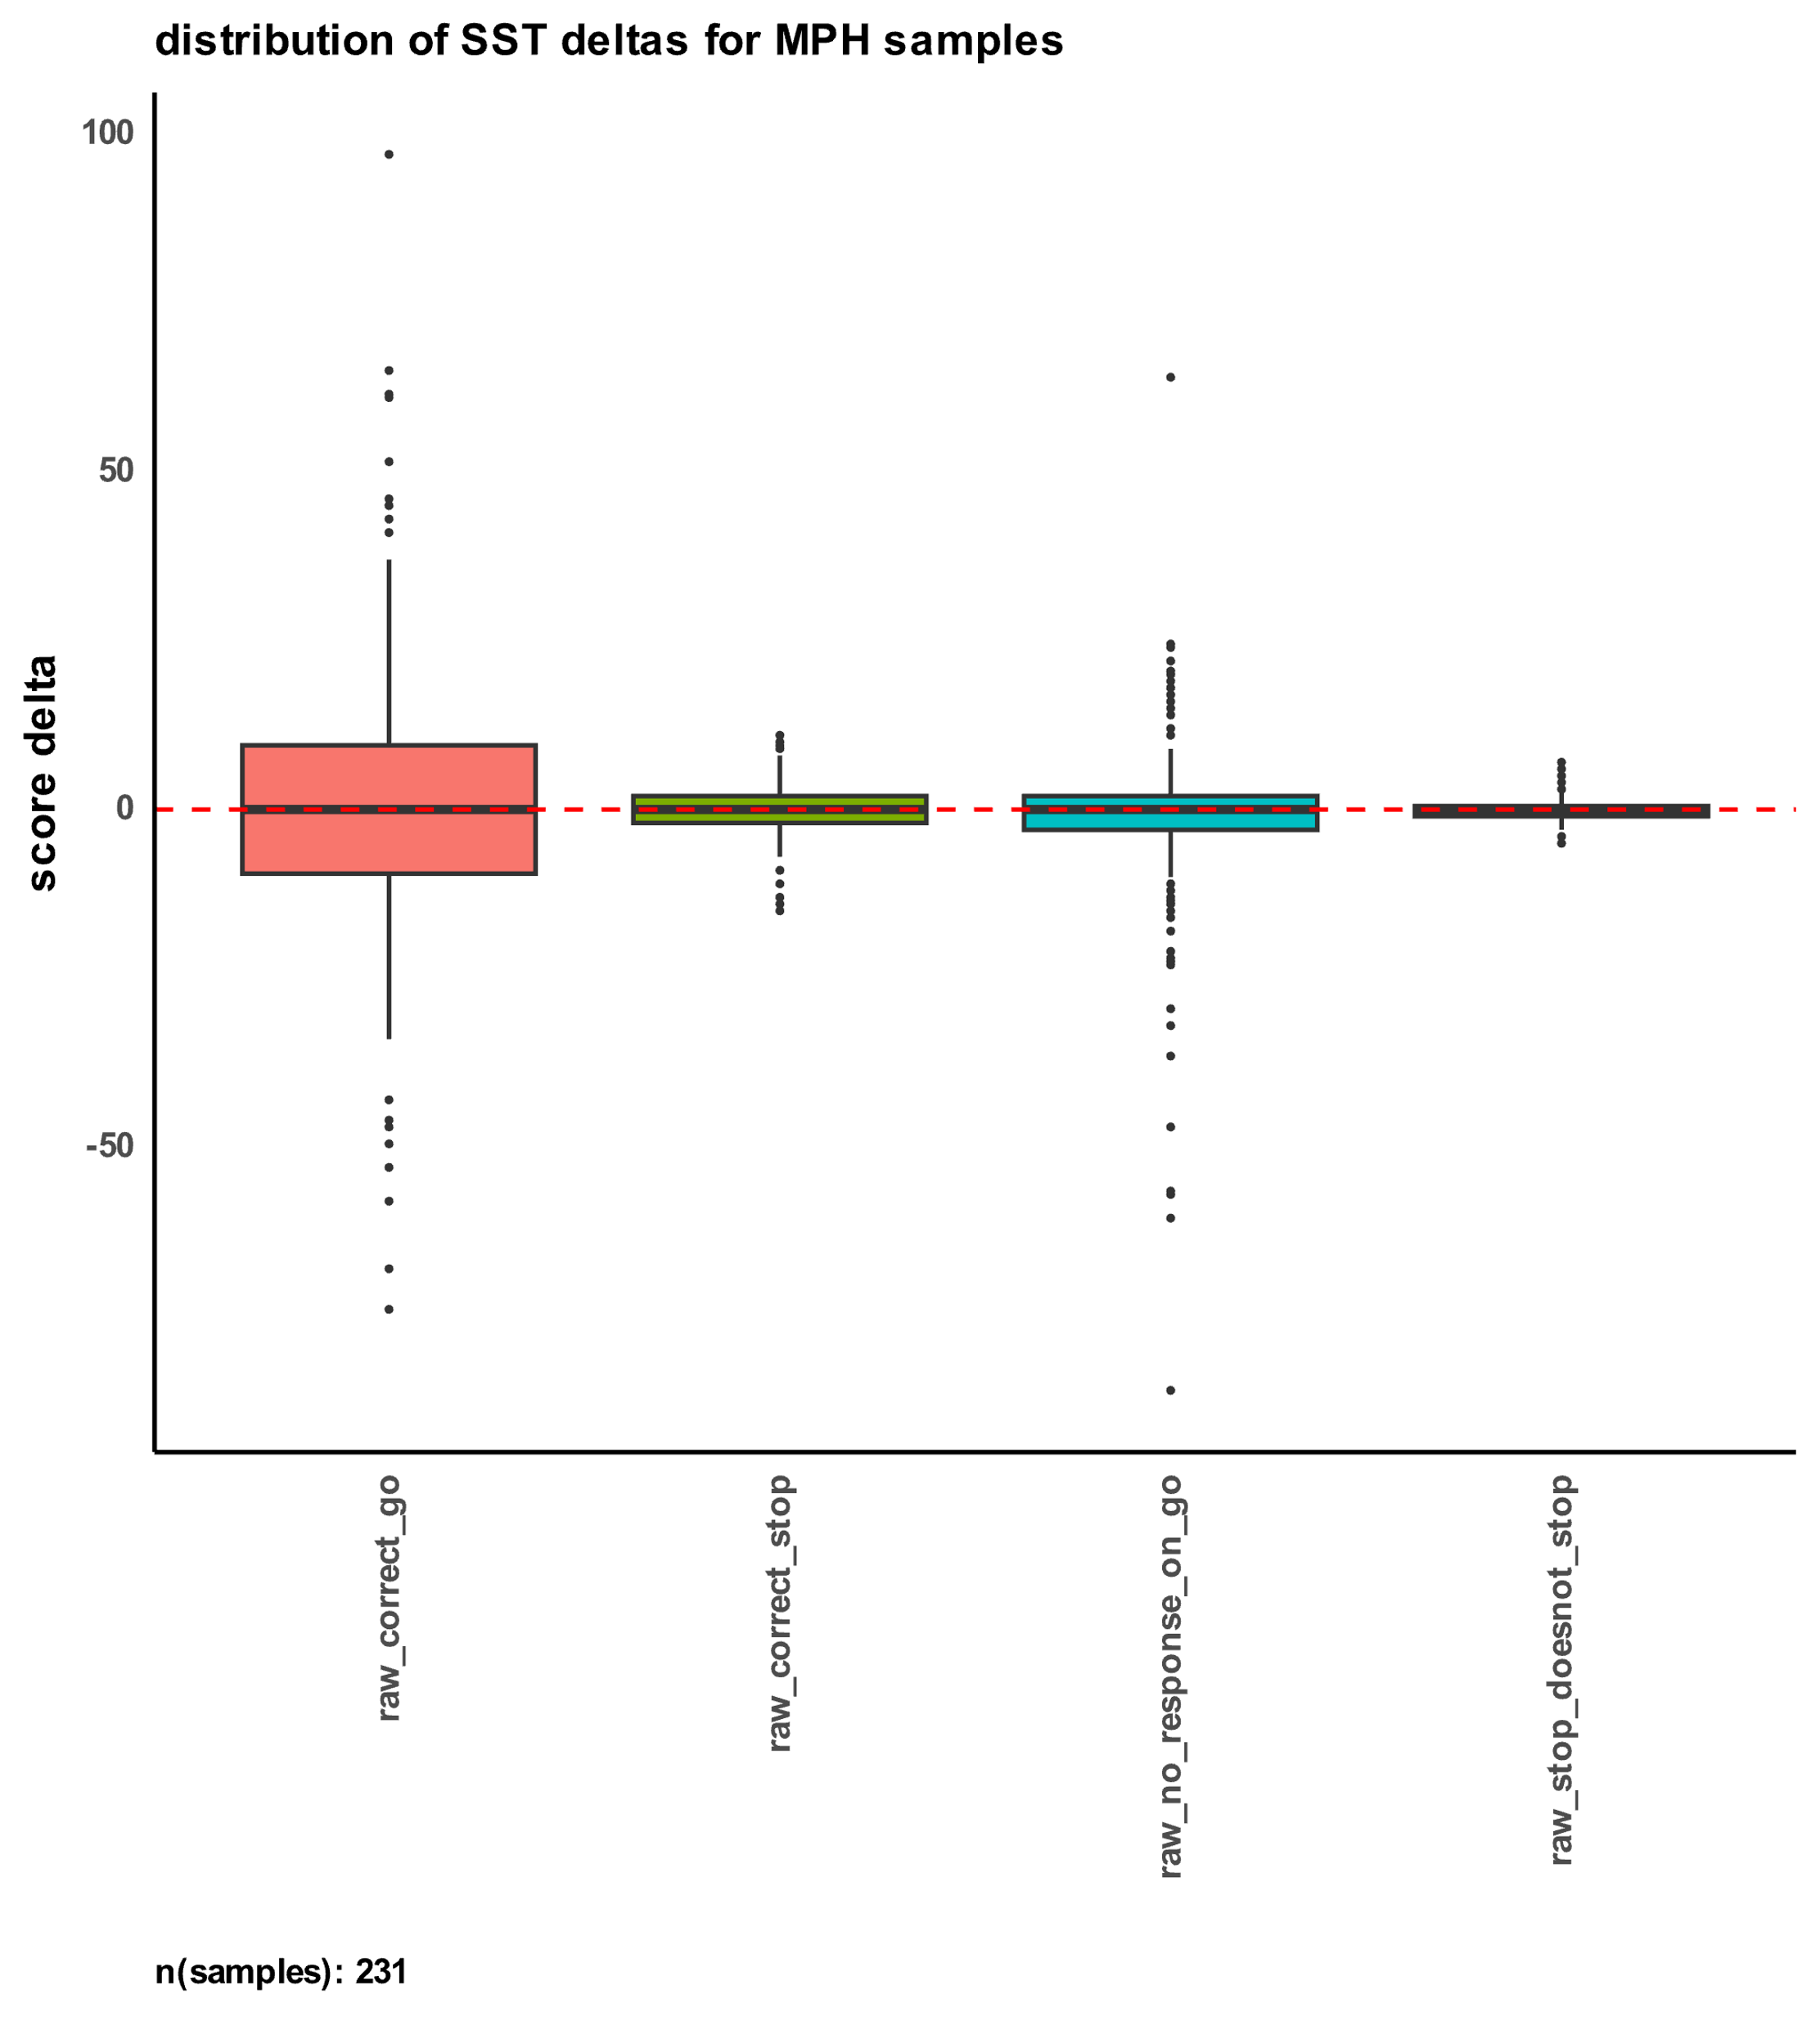

## 3.6. Predicting Drug Response using transcriptome imputation

To explore the feasibility of predicting drug response based on genetic signal, we developed a novel method that relies solely on the genetic profiles of individuals and the specific drug of interest. Utilizing eQTL weights, we imputed transcriptomic profiles specifically for excitatory neurons and compared them to the methylphenidate transcriptomic signature from the CMap database. The correlation between an individual's imputed transcriptome and the drug signature served as an indicator of drug effectiveness, with a negative correlation suggesting neutralization of the imputed transcriptome's effect, and a positive correlation indicating an exacerbation of gene expression in a similar direction to the imputed profile.

3.6.1. Correlation between predicted MPH response and PGS

After predicting participants' response to methylphenidate using this innovative pipeline, we assessed its correlation with the calculated PGS for ADHD and other cognitive traits as mentioned earlier. Remarkably, we found a significant (nominal p-value < 0.05) positive correlation between the predicted MPH response and cognitive PGS related to memory and reaction time (Figure 4-A). This finding suggests that individuals with higher genetic predisposition for better memory and reaction time may exhibit a more favorable response to methylphenidate treatment.

### 3.6.2. Performance in the SST

Intriguingly, we further examined the relationship between the predicted response to MPH from our pipeline and the performance of participants taking MPH in the stop signal fMRI task (SST), which provides an objective measure of inhibitory control. We discovered a strong negative correlation (nominal p-value < 0.05) between the predicted response and the change (delta) in the number of stop signals that participants failed to inhibit, even after correcting for age, sex, and their interaction (Figure 4-B). This observation implies that individuals predicted to respond positively to MPH generally demonstrated improved inhibitory control while on the drug.

3.6.3. Behavior changes in the CBCL

Delving further into participants' behavioral changes, we investigated the association between the predicted MPH response and alterations in their behavior problems as measured by the Child Behavior Checklist (CBCL). Our analysis revealed a substantial negative correlation (nominal p-value = 0.0134 for raw scores; nominal p-value = 0.031 after correction for age, sex, and their interaction) between the predicted response and the change (delta) in DSM5 ADHD symptoms (Figure 4-C). This indicates that individuals predicted to positively respond to MPH generally exhibited a reduction in ADHD symptoms while taking the drug.

These compelling results demonstrate the potential of transcriptome imputation-based prediction in identifying individuals who are more likely to respond positively to methylphenidate treatment.

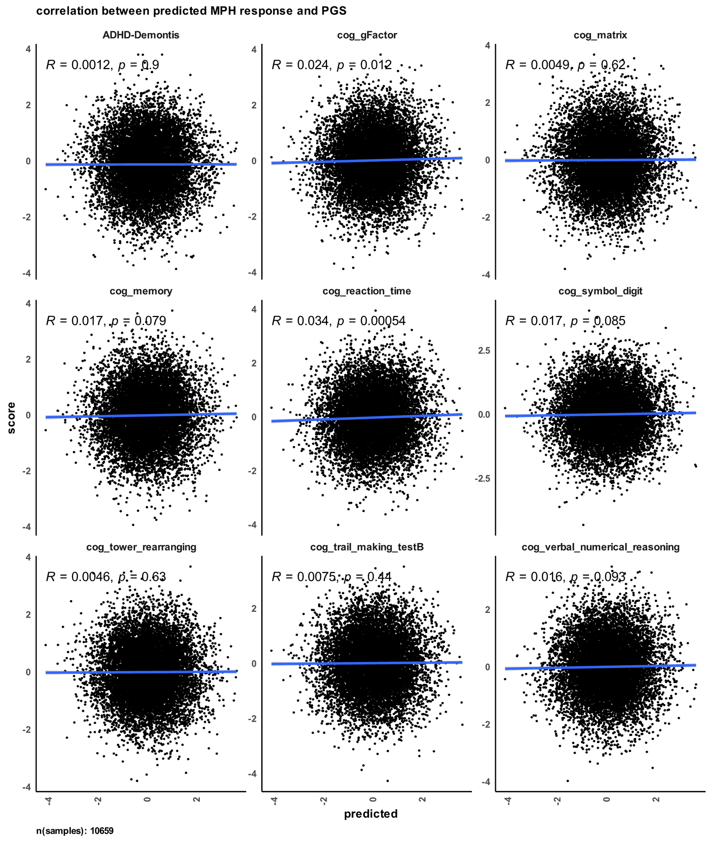

# 4. Discussion

The present study aimed to investigate factors contributing to variability in medication response among individuals with attention-deficit/hyperactivity disorder (ADHD). We employed a multi-faceted approach, combining polygenic scores (PGS) for cognitive traits and ADHD, transcriptome imputation-based drug response prediction, and correlation analyses with medication history and behavioral measures. Our findings shed light on the genetic basis underlying medication response and provide novel insights into the interplay between genetic factors, drug effectiveness, and cognitive abilities in the context of ADHD treatment.

Our initial analyses revealed a significant correlation between ADHD PGS and the use of stimulant medications (methylphenidate and amphetamines) in the SPARK cohort, supporting previous evidence of a genetic component influencing medication use. This suggests a potential genetic predisposition that might influence treatment-seeking behavior and medication response across a range of drugs. Additionally, we observed a negative correlation between cognitive PGS and the use of certain medications, indicating a potential association between genetic cognitive factors and medication choice.

Our investigation into the relationship between methylphenidate effectiveness and communication abilities (SCQ) revealed a significant correlation, indicating that the drug's effectiveness is related to the child's verbal communication skills. This suggests that methylphenidate may have a positive impact on communication abilities in certain individuals with ADHD, potentially aiding in social interactions and expressive language. Our analysis of cognitive impairment in SPARK participants uncovered a negative correlation between methylphenidate effectiveness and cognitive impairment. This finding suggests that individuals with cognitive impairments may experience lower effectiveness of methylphenidate treatment. This result has important implications for tailoring treatment strategies for individuals with cognitive deficits, highlighting the need for personalized approaches based on individual cognitive profiles.

In an effort to predict drug response based on genetic profiles, we developed a novel method using transcriptome imputation. Our pipeline successfully imputed transcriptomic profiles for excitatory neurons and correlated them with the methylphenidate transcriptomic signature from CMap to measure drug effectiveness. The positive correlation observed between predicted MPH response and cognitive PGS of memory and reaction time (Figure 4-A) provides evidence that genetic cognitive factors play a role in drug response. Additionally, the negative correlations observed in the SST and CBCL analyses (Figure 3-A, Figure 3-B) suggest that individuals with higher genetic cognitive advantages may disproportionately benefit from methylphenidate treatment.

Our study contributes to a deeper understanding of the genetic basis of medication response in ADHD. The positive correlations observed between specific cognitive PGS and methylphenidate response imply that cognitive genetic factors play a critical role in shaping the drug's effectiveness. These findings highlight the potential for using genetic information to tailor ADHD treatment strategies and optimize medication selection based on individual genetic profiles.

The transcriptome imputation-based drug response prediction pipeline offers a promising avenue for predicting drug effectiveness based solely on genetic data. Future studies could expand upon this approach to validate its accuracy and applicability in larger and more diverse cohorts. Moreover, investigating other genetic and environmental factors that might modulate drug response could provide additional insights into individual variability in medication effectiveness.

In conclusion, our study provides novel insights into the genetic basis of medication response in ADHD. We demonstrate the importance of considering genetic cognitive factors in determining drug effectiveness and propose a transcriptome imputation-based approach for predicting drug response. These findings have implications for personalized ADHD treatment strategies and highlight the potential of using genetic information to optimize medication selection for individuals with ADHD. Further research in larger and more diverse cohorts is warranted to validate and expand upon these findings, ultimately enhancing our understanding of medication response in ADHD and informing personalized treatment approaches.

# 5. Methods

## 5.1. Genotypes and polygenic scores for SPARK and ABCD

The genotyping and polygenic score methodologies employed in this study were previously documented in our group's publication (Taylor R Thomas, 2023).

### 5.1.1. Genotype quality control

Genotype quality control, imputation, and the computation of genetic principal components and polygenic scores were described in detail in (Taylor R. Thomas, 2022). The ABCD genotypes underwent quality control measures to address missingness and contamination before their official release. Hence, no additional quality control steps were conducted prior to genotype imputation. As for SPARK, we utilized the genotypes from the integrated whole-exome sequencing (iWES1) 2022 Release, along with the SPARK whole-genome sequencing (WGS) Releases 2, 3, and 4. The SPARK iWES1 dataset (N = 69,592) had already undergone quality control, including the removal of samples exhibiting heterozygosity or high missingness. Thus, no further quality control was performed by our team before genotype imputation. Moreover, the SPARK iWES1 dataset provided genetic ancestry assignments based on the 1000 Genomes populations (Genomes Project et al., 2015).

In contrast, SPARK WGS Releases 2 (N = 2,365), 3 (N = 2,871), and 4 (N = 3,684) were not subjected to quality control upon release. Consequently, we conducted quality control using PLINK (Purcell et al., 2007) before proceeding with genotype imputation. Our quality control process involved the exclusion of participants already present in the iWES1 dataset. Additionally, we eliminated variants and participants exhibiting missingness greater than 0.1 and 0.2, respectively. Subsequently, we merged the three WGS releases and excluded any participant whose heterozygosity (F statistic) deviated more than 3 standard deviations from the mean heterozygosity across the three releases. We employed the TopMed reference panel (Taliun et al., 2021) to identify strand flips. Ultimately, the final sample size for WGS 2-4 comprised N = 8,152 individuals.

### 5.1.2. Genotype imputation and merging

We employed the Michigan Imputation Server (Das et al., 2016)to impute the genotypes of ABCD, SPARK iWES1, and quality-controlled SPARK WGS 2-4 datasets to the TopMed reference panel (Taliun et al., 2021). Imputation was carried out using phasing and quality control steps, yielding variants with an imputation quality r2 > 0.3. Following imputation, the variants were filtered to retain only the HapMap SNPs (N = 1,054,330 variants) with an imputation quality r2 > 0.8, utilizing bcftools (Danecek et al., 2021). The variants were then converted from the hg38 to hg19 reference genome using the VCF-liftover tool (<https://github.com/hmgu-itg/VCF-liftover>), and their alleles were normalized accordingly. Finally, the files were merged, and only variants with 0% missingness were retained, resulting in a final dataset size of N = 914,328 variants.

### 5.1.3. Genetic ancestry and principal components

To compute the genetic principal components (PCs), we utilized the bigsnpr package (Prive et al., 2018) following the recommended guidelines outlined by the authors (Prive et al., 2020). For a detailed tutorial, we followed the steps provided in their documentation: [link: <https://privefl.github.io/bigsnpr/articles/bedpca.html>]. In summary, the following steps were performed:

1. We employed the snp_plinkKINGQC function to identify and exclude related participants using the KING threshold of 2-3.5

2. Principal component analysis (PCA) was conducted using the bed_autoSVD function solely on unrelated participants.

3. Outliers among the principal components were detected and subsequently removed.

4. The principal components were recalculated.

5. The bed_projectSelfPCA function was used to project the principal components onto the entire cohort.

To assign genetic ancestry, we performed k-means clustering utilizing the top 40 principal components, with K set to 5 to correspond to the five populations identified in the 1000 Genomes project (Genomes Project et al., 2015). The genetic ancestry labels from the iWES1 dataset were employed to assign labels to the five genetic population clusters.

### 5.1.4. Polygenic score calculations

Polygenic scores (PGS) were calculated using LDpred2 (Prive et al., 2021) and the bigsnpr tools (Prive et al., 2018) in R (R-Core-Team). As SPARK is a family-based dataset, we utilized an external LD reference based on 362,320 individuals from the UK Biobank, provided by the authors of LDpred2. This reference was used to calculate the genetic correlation matrix, estimate heritability, and calculate infinitesimal beta weights.

The PGS were derived from the following individual genome-wide association studies (GWAS) ADHD (Demontis et al., 2019). Additionally, the PGS for the eight cognitive traits (fluid intelligence (verbal_numerical reasoning), matrix pattern completion (matrix), tower rearranging (tower_rearranging), numeric memory (mem), reaction time (reaction_time), symbol digit substitution (symbol_digit), trail making (trail_making), and a G factor score (gFactor)) were obtained from the same study (de la Fuente et al., 2021).

To account for potential confounding effects, we conducted linear regression residualization by incorporating the first five genetic principal components. Subsequently, the PGS were Z-scaled to have a mean of 0 and a standard deviation (σ) of 1.

## 5.2. SPARK methylphenidate effectiveness correlations

### 5.2.1. SPARK participants

## For our analysis of methylphenidate (MPH) effectiveness, we utilized a survey that was administered to a subset of SPARK participants. The survey, completed by parents, focused on aspects such as sleep patterns, eating habits, and gastrointestinal issues in their children. Among the questions, one specifically targeted the medical history of the child and assessed the effectiveness of methylphenidate as a binary variable: 0 for not effective and 1 for effective. The classification was solely based on the perceived effectiveness of the drug without considering any potential adverse effects. Participants were asked about the drug's effectiveness, irrespective of whether they were currently taking it or had taken it in the past.

We utilized the data collected from this question as the predicted response for drug effectiveness and compared it to other surveys conducted by SPARK for the same participants. The sample included 1460 participants, with a mean age of 160.580 months (SD = 65.164).

|  |  |  |  |  |  |
| --- | --- | --- | --- | --- | --- |
| **sex** | **avg** | **sd** | **min** | **max** | **count** |
| **Female** | 146.65968586387400 | 40.709554004793800 | 36 | 234 | 191 |
| **Male** | 140.00224215246600 | 40.03259047628670 | 55 | 233 | 892 |

|  |  |  |  |  |
| --- | --- | --- | --- | --- |
| Question | No | Yes | Odds Ratio | p-value |
| MPH effect | 435 | 683 | - | - |
| q01_phrases | 72 | 1046 | 2.1870605 | 0.001637545 |

### 5.2.2. social communication questionnaire

In addition to the effectiveness survey, parents also reported data from the Social Communication Questionnaire (SCQ) for the same participants. The SCQ is a reliable screening tool used to assess social communication abilities and identify potential indicators of autism spectrum disorder (ASD). Comprising 40 structured questions, the SCQ evaluates various aspects of social interaction, communication skills, and behavioral patterns commonly associated with ASD. It covers areas such as eye contact, gestures, facial expressions, reciprocal conversation, interests, and repetitive behaviors. The SCQ offers a comprehensive evaluation of social communication abilities, making it valuable for research investigations and clinical assessments of ASD. Each question in the SCQ is answered with a yes or no response.

To examine the relationship between MPH effectiveness and individual SCQ questions, we conducted Fisher's Exact tests using the 'fisher.test()' function in R for each question independently. We extracted the odds ratio and nominal p-value from these tests. The table below summarizes the sample included in the analysis and reports the questions with significant odds ratios associated with MPH effectiveness.

**Table 1 social communication questionnaire associations with MPH effectiveness**

|  |  |  |  |  |
| --- | --- | --- | --- | --- |
| Question | No | Yes | Odds Ratio | p-value |
| MPH effect | 482 | 758 | - | - |
| q01_phrases | 82 | 1155 | 2.0753643 | 0.0019874569 |
| q15_odd_ways | 380 | 855 | 0.66784639 | 0.0019272163 |
| q17_injured_deliberately | 549 | 685 | 0.77794502 | 0.0344979721 |
| q24_nod_head | 402 | 833 | 1.31400727 | 0.0292520573 |
| q25_shake_head | 350 | 882 | 1.48568113 | 0.0023010170 |

|  |  |  |  |  |  |
| --- | --- | --- | --- | --- | --- |
| **Sex** | Age avg | Age sd | Age min | Age max | Samples count |
| Female | 146.65968586387400 | 40.709554004793800 | 36 | 234 | 191 |
| Male | 140.00224215246600 | 40.03259047628670 | 55 | 233 | 892 |

### 5.2.3. cognitive impairment

To explore the association between MPH effectiveness and cognitive impairment among the participants, we conducted a Fisher's Exact test. The cognitive impairment variable was derived as a binary vector from the SPARK cohort: 0 denoting no cognitive impairment and 1 indicating cognitive impairment. This variable served as a predictor for multiple measurements in the participants. The table below presents a summary of the sample included in this section.

**Table 2 cognitive impairment counts for participants with reported MPH effectiveness**

|  |  |  |
| --- | --- | --- |
| Question | No | Yes |
| MPH effect | 548 | 862 |
| derived_cog_impair | 593 | 817 |

### 5.2.4. polygenic scores

After adjusting the polygenic scores (PGS) for all ABCD and SPARK participants using the first five genetic principal components, we specifically included participants who had reported MPH effectiveness in the SPARK dataset. Subsequently, we examined the correlation between PGS and MPH effectiveness using the 'cor()' function in R. The reported values in Figure 1-C represent the Spearman's rank-based correlation coefficients along with their nominal p-values.

## 5.3. ABCD cohort

The present study utilized data from the Adolescent Brain Cognitive Development (ABCD) dataset, release 5.0, a comprehensive and longitudinal study conducted in the United States. The primary objective of the ABCD dataset is to examine brain development in relation to behavioral, cognitive, and social outcomes among adolescents. The dataset comprises a diverse sample of over 11,000 children, initially aged 9 to 10 years at baseline, who are followed through adolescence with multiple assessments conducted over several years. These assessments cover a wide range of domains, including neuroimaging, neurocognitive testing, psychosocial questionnaires, and physical health measures. By incorporating these various assessments, the ABCD study provides a multidimensional dataset that facilitates investigations into different aspects of brain development and associated outcomes during the crucial period of adolescence.

### 5.3.1. Stop signal fMRI task.

In the ABCD dataset, the Stop Signal fMRI Task (SST) was utilized to assess inhibitory control and impulsivity in adolescents. This task measures the ability to inhibit prepotent responses by presenting participants with a series of go trials where they need to respond quickly to a specific stimulus. On certain trials, a stop signal is presented after the go signal, indicating that participants should inhibit their response. By manipulating the timing of the stop signal, researchers can estimate the stop signal reaction time (SSRT), which reflects the individual's ability to successfully inhibit their responses. The SST provides valuable insights into the neural mechanisms underlying inhibitory control and impulsivity, contributing to the understanding of cognitive processes related to behavioral regulation in the ABCD study.

During the SST, typically two trial runs are conducted to familiarize participants with the task and obtain reliable measurements of inhibitory control. The first trial run serves as an introduction to the task instructions and structure, allowing participants to become comfortable and understand the requirements for response inhibition. For this analysis, we focused on the data from the first run since most participants did not complete the second run.

We extracted specific variables of interest from the evaluated SST data as measures of attention. These variables include the number of correct and incorrect go answers within the specified time, the number of no responses on go trials, and the number of stop signal doesn't stop trials.

These variables were found to have a significant correlation with the interview age of the participants, and their sex. To account for that, we conducted a regression analysis using the glm() function in R, fitting the formula glm(y ~ interview_age + sex + interview_age:sex, family = poisson()) and obtaining the residuals.

For each one of the questions, we calculated the change (delta) in participant’s performance based on the status of taking MPH or not. The delta was defined as: (participant’s score on MPH) - (participant’s score off MPH)

For participants that had multiple measures per MPH status, their score was averaged.

|  |  |  |  |  |  |  |
| --- | --- | --- | --- | --- | --- | --- |
| **Sex** | Drug | Age avg | Age sd | Age min | Age max | Samples count |
| Female | amphetamine | 137.13392857142900 | 19.437817480140300 | 108 | 185 | 48 |
| Female | atomoxetine | 136.19354838709700 | 20.645288978099800 | 108 | 178 | 13 |
| Female | clonidine | 139.0408163265310 | 20.483691870682400 | 107 | 182 | 20 |
| Female | concerta | 138.86458333333300 | 20.18525766971980 | 107 | 185 | 40 |
| Female | guanfacine | 137.17857142857100 | 19.2515474163008 | 108 | 185 | 25 |
| Female | lisdexamfetamine | 135.15277777777800 | 19.49695514127550 | 108 | 185 | 31 |
| Female | methylphenidate | 136.3227848101270 | 18.894028641612800 | 107 | 186 | 70 |
| Male | amphetamine | 138.27906976744200 | 19.893286020747900 | 108 | 186 | 106 |
| Male | atomoxetine | 137.81690140845100 | 21.020608839323700 | 108 | 186 | 29 |
| Male | clonidine | 138.65853658536600 | 19.15577436855890 | 108 | 186 | 35 |
| Male | concerta | 140.0557768924300 | 20.020711188517400 | 107 | 186 | 103 |
| Male | guanfacine | 139.28494623655900 | 20.086017437102400 | 108 | 183 | 77 |
| Male | lisdexamfetamine | 140.4267782426780 | 21.24907003592850 | 107 | 188 | 95 |
| Male | methylphenidate | 138.05026455026500 | 19.287717190289400 | 107 | 186 | 161 |

### 5.3.2. Child Behavior Checklist (CBCL)

In addition to the Stop Signal fMRI Task (SST), the ABCD dataset includes parent-reported data on their child's behavior using the Child Behavior Checklist (CBCL). The CBCL is a widely used questionnaire that assesses various behavioral and emotional problems in children and adolescents. Parents provide ratings on a range of behavioral items, allowing for the assessment of different behavioral domains.

To investigate the effects of methylphenidate on behavior, we calculated the change (delta) in CBCL subscale scores based on the status of taking MPH or not. Similar to the SST analysis, the delta was defined as: (participant's CBCL subscale score on MPH) - (participant's CBCL subscale score off MPH)

As some participants had multiple measures per MPH status, their scores were averaged. To account for age and sex, which are known to influence behavioral outcomes, we conducted a regression analysis using the glm() function in R. The formula glm(y ~ interview_age + sex + interview_age:sex, family = poisson()) was used to obtain the residuals. These residuals represent the change in CBCL subscale scores, adjusted for age and sex, which allowed us to examine the effect of taking MPH on behavioral outcomes independently of age and sex influences.

|  |  |  |  |  |  |  |
| --- | --- | --- | --- | --- | --- | --- |
| **Sex** | Drug | Age avg | Age sd | Age min | Age max | Samples count |
| Female | amphetamine | 139.28938906752400 | 18.304234921929100 | 108 | 185 | 77 |
| Female | atomoxetine | 139.16666666666700 | 18.15915802234020 | 108 | 179 | 20 |
| Female | clonidine | 138.26168224299100 | 18.10313037070750 | 107 | 182 | 27 |
| Female | concerta | 141.5191637630660 | 18.238670647571100 | 107 | 185 | 66 |
| Female | guanfacine | 139.06201550387600 | 17.638625911079600 | 108 | 185 | 33 |
| Female | lisdexamfetamine | 136.1898148148150 | 17.401312112061 | 108 | 185 | 54 |
| Female | methylphenidate | 140.38307349665900 | 18.09499433536300 | 107 | 186 | 109 |
| Male | amphetamine | 139.775204359673 | 18.060603930962200 | 107 | 186 | 181 |
| Male | atomoxetine | 140.57731958762900 | 19.02130523601870 | 108 | 186 | 46 |
| Male | clonidine | 139.875 | 17.13121747475350 | 108 | 186 | 69 |
| Male | concerta | 141.61668839634900 | 18.282284166518600 | 107 | 186 | 180 |
| Male | guanfacine | 140.506993006993 | 18.019884523148900 | 107 | 183 | 142 |
| Male | lisdexamfetamine | 141.64948453608200 | 18.72725217206960 | 107 | 188 | 137 |
| Male | methylphenidate | 140.65599268069500 | 18.120542984852300 | 107 | 186 | 266 |

### 5.3.3. Polygenic scores

After adjusting the polygenic scores (PGS) for all participants in the SPARK and ABCD cohorts using the first five genetic principal components, we focused on participants from the ABCD dataset who had reported performance data in the first run of the SST. We then examined the correlation between the PGS and the calculated deltas for both: the SST, and the CBCL. The correlation was performed in R, using the ‘cor()’ function with specifying the method to be Spearman rank-based correlation.

## 5.4. Transcriptome imputation

To investigate how different genetic variants influence gene expression in specific cell types, we utilized cis-eQTL weights obtained from (Bryois et al., 2022). These weights were assigned to each variant-gene pair and were derived using a specific statistical model that accounted for various factors such as genotype, cell type, principal components, study, disease status, and individual-specific random effects. The eQTLs were derived by the following model as defined by the authors:

$raw counts (each gene)\sim genotype (0,1,2)+ cell_type+ genotype:cell_type_eqtl (cell type in which the eQTL was discovered, coded as 0,1)+ PC 1-3 genotype matrix + PC 1-5 expression matrix + study + disease_status+ (1│individual)(random effect)$

The study provided cis-eQTL weights for eight different cell types, including astrocytes, endothelial cells, excitatory neurons, inhibitory neurons, microglia, oligodendrocytes, OPCs (oligodendrocyte progenitor cells), and pericytes. However, for our investigation into methylphenidate response, we focused solely on excitatory neurons. To narrow down the list of eQTLs, we filtered them based on a false discovery rate (FDR) threshold of less than 0.05, resulting in a final set of 328,061 unique significant eQTLs out of the original 2,438,542 eQTLs.

To impute gene expression in excitatory neurons for individuals, we performed a simple matrix multiplication using the following formula:

$Imputed_tx= Genotypes_Matrix x cell_type_Weights_Matrix$

The cell_type_Weights_Matrix represents the weights matrix derived from (Bryois et al., 2022). It has dimensions MxN, where M represents the number of variants and N represents the number of genes. The Genotypes_Matrix, on the other hand, has rows representing individuals and columns representing genotypes. The values in this matrix indicate the type of genotype alleles found for each individual (0 for homozygous reference, 1 for heterozygous, and 2 for homozygous alternate).

For our analysis, we used the Genotypes_Matrix specific to participants from the Adolescent Brain Cognitive Development (ABCD) study. The ABCD study is one of the largest long-term studies funded by the National Institutes of Health (NIH) that focuses on brain development and child health in the United States. It includes approximately 11,000 children aged 9-10 years at the beginning of the study.

After imputing transcriptome data for the ABCD participants, we further standardized the imputed values on a gene level by z-scaling them, ensuring a mean of 0 and a standard deviation (σ) of 1. This normalization step allows for easier interpretation and comparison of gene expression levels across individuals.

## 5.5. Drug response

### 5.5.1. calculating polygenic drug response

To assess individuals' response to methylphenidate (MPH), we calculated the correlation between their imputed transcriptome in excitatory neurons and the drug signature obtained from the connectivity map (CMap)[3] database developed by the BROAD Institute. The CMap database provides a measure of cellular response to different perturbagens (including drugs) in various cell lines.

The drug signature matrix for each drug is a 1xG matrix, where G represents the total number of genes with measured gene expression after introducing the drug to the cell line. The gene expression values in the signature matrix range from 0 to 1, representing fluorescence intensity. For our analysis, we used the fitted data from the CMap, which controls for the cell line and drug dose, ensuring that the signature reflects the drug effect specifically.

To calculate the correlation, we employed the cor() function in R, specifically using Spearman rank-based correlation. This correlation measures how different an individual's imputed gene expression is compared to the drug signature. Before calculating the correlation, we accounted for genes that had a measured change in the drug signature but did not have imputed transcriptome values (either due to a lack of eQTLs found in the sample or the gene not having significant eQTLs with weights). In these cases, we added those genes to the imputed transcriptome vector with a value of 0.

The calculated correlations serve as a measure of how an individual's imputed gene expression differs from the drug signature. Based on these correlations, individuals were categorized as positive responders to the drug if their imputed tissue expression had a negative correlation with the drug perturbation signature. Conversely, individuals were categorized as negative responders if they had a positive correlation. In this context, a negative correlation indicates that the drug is expected to reverse the imputed transcriptome, thereby normalizing the gene expression.

To ensure consistency in the interpretation, we multiplied the calculated correlations by -1 to reverse the sign. Thus, a positive value in the correlation indicates that an individual is predicted to be a responder to methylphenidate (MPH).

5.5.2. comparing predicted polygenic MPH response to participants’ performance on SST and their CBCL deltas

To assess the relationship between the predicted polygenic response to methylphenidate (MPH) and participants' performance in the Stop Signal fMRI Task (SST) as well as their CBCL deltas, we conducted Spearman’s rank-based correlation analyses using the cor() function in R.

# 6. Limitations

Several limitations should be considered when interpreting the findings of this study. Firstly, the use of subjective reporting for MPH effectiveness and social communication abilities relies on the accuracy of parent reports, which can be influenced by various factors such as recall bias or subjective perceptions. Objective measures, although employed in the validation stage, still have inherent limitations, and may not fully capture the complexity of drug response in real-world settings.

Another limitation is the reliance on transcriptomic imputation for predicting drug response. While this approach provides valuable insights into gene expression patterns, it relies on the assumption that imputed values accurately represent the true transcriptomic profile of the individual. It is also worth noting that the eQTL weights were derived from postmortem samples. The imputation process itself introduces inherent uncertainty and potential biases, which may affect the accuracy of the predicted drug response.

Furthermore, the study's sample size, although representative of the targeted populations, may limit the generalizability of the findings. The SPARK and ABCD cohorts, while providing valuable data, may not fully capture the diversity and heterogeneity present in the broader population of individuals with neurodevelopmental disorders.

Additionally, the regression models used in this study are based on associations and correlations and do not establish causality. Other factors beyond the genetic and transcriptomic profiles, such as environmental influences or individual-specific physiological processes, could contribute to the observed drug response variations.

Lastly, it is worth noting that the study focused specifically on methylphenidate response in individuals with neurodevelopmental disorders. The generalizability of the findings to other medications or different patient populations requires further investigation.

These limitations highlight the need for caution when interpreting the results and suggest avenues for future research. Larger and more diverse cohorts, rigorous validation of predictive models, and longitudinal studies assessing the long-term effects of predicted drug response are essential to further refine and validate the proposed method for personalized pharmacological management in neurodevelopmental disorders.

# 7. Acknowledgements

Data used in the preparation of this article were obtained from the Adolescent Brain Cognitive DevelopmentSM (ABCD) Study (https://abcdstudy.org), held in the NIMH Data Archive (NDA). This is a multisite, longitudinal study designed to recruit more than 10,000 children age 9-10 and follow them over 10 years into early adulthood. The ABCD Study® is supported by the National Institutes of Health and additional federal partners under award numbers U01DA041048, U01DA050989, U01DA051016, U01DA041022, U01DA051018, U01DA051037, U01DA050987, U01DA041174, U01DA041106, U01DA041117, U01DA041028, U01DA041134, U01DA050988, U01DA051039, U01DA041156, U01DA041025, U01DA041120, U01DA051038, U01DA041148, U01DA041093, U01DA041089, U24DA041123, U24DA041147. A full list of supporters is available at <https://abcdstudy.org/federal-partners.html>. A listing of participating sites and a complete listing of the study investigators can be found at<https://abcdstudy.org/consortium_members/>. ABCD consortium investigators designed and implemented the study and/or provided data but did not necessarily participate in the analysis or writing of this report. This manuscript reflects the views of the authors and may not reflect the opinions or views of the NIH or ABCD consortium investigators.

The ABCD data repository grows and changes over time. The ABCD data used in this report came from [NIMH Data Archive Digital Object Identifier [10.15154/8873-zj65](http://dx.doi.org/10.15154/8873-zj65)]. DOIs can be found at https://nda.nih.gov/abcd.

The SPARK data can be obtained at SFARI Base: <https://base.sfari.org>.

# 8. Data availability

The data used in this study is subject to data access and sharing policies set forth by the respective cohorts and databases. The SPARK (Simons Foundation Powering Autism Research for Knowledge) cohort data can be accessed through an application process via the SPARK website (https://sparkforautism.org/). Researchers interested in accessing the ABCD (Adolescent Brain Cognitive Development) cohort data can submit data access requests to the ABCD Study Data Repository (https://nda.nih.gov/abcd).

The imputation weights used in this study are derived from publicly available resources. The specific sources and versions of the genetic data are detailed in the Methods section. Researchers can access these resources directly to obtain the necessary genetic information.

The connectivity map (CMap) drug perturbation signature data used to compute drug response correlations can be obtained from the BROAD Institute's CMap website (https://clue.io/).

Due to the sensitive nature of the participant data, including clinical and behavioral information, access to individual-level data from the SPARK and ABCD cohorts may require adherence to ethical and privacy considerations. Researchers interested in accessing the individual-level data should consult the respective cohort data access policies and procedures, ensuring compliance with relevant legal and ethical guidelines.

In summary, access to the data used in this study is subject to the policies and procedures of the SPARK and ABCD cohorts, as well as the availability of publicly accessible resources. Researchers can refer to the cohort websites and associated repositories for detailed information on data access and availability.

**9. Code availability**

To promote transparency and reproducibility, the code used for data analysis, statistical modeling, and generation of results and figures can be found here [link].

# 10. Funding

[ask Jake]

# 11. Conflicts of interest

The authors declare that the research was conducted in the absence of any commercial or financial relationships that could be construed as a potential conflict of interest.

# 12. Author contributions

ME contributed to the study design, generating the imputed transcriptome, predicting drug response, processing the data, performing the statistical analyses, and writing the manuscript. TRT contributed to processing the data, genotype imputations, generating the polygenic scores, and writing the manuscript. LCG contributed to processing the data. JJM contributed to study design and writing the manuscript.

# 13. References

American-Academy-of-Pediatrics. (2022). Common ADHD Medications & Treatments for Children. Retrieved 06/19/2023, from <https://www.healthychildren.org/English/health-issues/conditions/adhd/Pages/Determining-ADHD-Medication-Treatments.aspx>

Belle, D. J., & Singh, H. (2008). Genetic factors in drug metabolism. *Am Fam Physician*, *77*(11), 1553-1560. <https://www.ncbi.nlm.nih.gov/pubmed/18581835>

Bryois, J., Calini, D., Macnair, W., Foo, L., Urich, E., Ortmann, W., Iglesias, V. A., Selvaraj, S., Nutma, E., Marzin, M., Amor, S., Williams, A., Castelo-Branco, G., Menon, V., De Jager, P., & Malhotra, D. (2022). Cell-type-specific cis-eQTLs in eight human brain cell types identify novel risk genes for psychiatric and neurological disorders. *Nat Neurosci*, *25*(8), 1104-1112. <https://doi.org/10.1038/s41593-022-01128-z>

CDC, C. f. D. C. a. P. (2022, August 9, 2022). *Data and Statistics About ADHD*. CDC. Retrieved June 16th from <https://www.cdc.gov/ncbddd/adhd/data.html>

Chang, J. C., Lin, H. Y., Lv, J., Tseng, W. I., & Gau, S. S. (2021). Regional brain volume predicts response to methylphenidate treatment in individuals with ADHD. *BMC Psychiatry*, *21*(1), 26. <https://doi.org/10.1186/s12888-021-03040-5>

Cortese, S., Adamo, N., Del Giovane, C., Mohr-Jensen, C., Hayes, A. J., Carucci, S., Atkinson, L. Z., Tessari, L., Banaschewski, T., Coghill, D., Hollis, C., Simonoff, E., Zuddas, A., Barbui, C., Purgato, M., Steinhausen, H. C., Shokraneh, F., Xia, J., & Cipriani, A. (2018). Comparative efficacy and tolerability of medications for attention-deficit hyperactivity disorder in children, adolescents, and adults: a systematic review and network meta-analysis. *Lancet Psychiatry*, *5*(9), 727-738. <https://doi.org/10.1016/S2215-0366(18)30269-4>

Danecek, P., Bonfield, J. K., Liddle, J., Marshall, J., Ohan, V., Pollard, M. O., Whitwham, A., Keane, T., McCarthy, S. A., Davies, R. M., & Li, H. (2021). Twelve years of SAMtools and BCFtools. *Gigascience*, *10*(2). <https://doi.org/10.1093/gigascience/giab008>

Das, S., Forer, L., Schonherr, S., Sidore, C., Locke, A. E., Kwong, A., Vrieze, S. I., Chew, E. Y., Levy, S., McGue, M., Schlessinger, D., Stambolian, D., Loh, P. R., Iacono, W. G., Swaroop, A., Scott, L. J., Cucca, F., Kronenberg, F., Boehnke, M., . . . Fuchsberger, C. (2016). Next-generation genotype imputation service and methods. *Nat Genet*, *48*(10), 1284-1287. <https://doi.org/10.1038/ng.3656>

de Faria, J. C. M., Duarte, L. J. R., Ferreira, L. A., da Silveira, V. T., Menezes de Padua, C., & Perini, E. (2022). "Real-world" effectiveness of methylphenidate in improving the academic achievement of Attention-Deficit Hyperactivity Disorder diagnosed students-A systematic review. *J Clin Pharm Ther*, *47*(1), 6-23. <https://doi.org/10.1111/jcpt.13486>

de la Fuente, J., Davies, G., Grotzinger, A. D., Tucker-Drob, E. M., & Deary, I. J. (2021). A general dimension of genetic sharing across diverse cognitive traits inferred from molecular data. *Nat Hum Behav*, *5*(1), 49-58. <https://doi.org/10.1038/s41562-020-00936-2>

Demontis, D., Walters, R. K., Martin, J., Mattheisen, M., Als, T. D., Agerbo, E., Baldursson, G., Belliveau, R., Bybjerg-Grauholm, J., Baekvad-Hansen, M., Cerrato, F., Chambert, K., Churchhouse, C., Dumont, A., Eriksson, N., Gandal, M., Goldstein, J. I., Grasby, K. L., Grove, J., . . . Neale, B. M. (2019). Discovery of the first genome-wide significant risk loci for attention deficit/hyperactivity disorder. *Nat Genet*, *51*(1), 63-75. <https://doi.org/10.1038/s41588-018-0269-7>

Dunnenberger, H. M., Crews, K. R., Hoffman, J. M., Caudle, K. E., Broeckel, U., Howard, S. C., Hunkler, R. J., Klein, T. E., Evans, W. E., & Relling, M. V. (2015). Preemptive clinical pharmacogenetics implementation: current programs in five US medical centers. *Annu Rev Pharmacol Toxicol*, *55*, 89-106. <https://doi.org/10.1146/annurev-pharmtox-010814-124835>

Evans, W. E., & Johnson, J. A. (2001). Pharmacogenomics: the inherited basis for interindividual differences in drug response. *Annu Rev Genomics Hum Genet*, *2*, 9-39. <https://doi.org/10.1146/annurev.genom.2.1.9>

Genomes Project, C., Auton, A., Brooks, L. D., Durbin, R. M., Garrison, E. P., Kang, H. M., Korbel, J. O., Marchini, J. L., McCarthy, S., McVean, G. A., & Abecasis, G. R. (2015). A global reference for human genetic variation. *Nature*, *526*(7571), 68-74. <https://doi.org/10.1038/nature15393>

Grazioli, S., Rosi, E., Mauri, M., Crippa, A., Tizzoni, F., Tarabelloni, A., Villa, F. M., Chiapasco, F., Reimers, M., Gatti, E., Bertella, S., Molteni, M., & Nobile, M. (2021). Patterns of Response to Methylphenidate Administration in Children with ADHD: A Personalized Medicine Approach through Clustering Analysis. *Children (Basel)*, *8*(11). <https://doi.org/10.3390/children8111008>

Ingelman-Sundberg, M., Mkrtchian, S., Zhou, Y., & Lauschke, V. M. (2018). Integrating rare genetic variants into pharmacogenetic drug response predictions. *Hum Genomics*, *12*(1), 26. <https://doi.org/10.1186/s40246-018-0157-3>

Kimko, H. C., Cross, J. T., & Abernethy, D. R. (1999). Pharmacokinetics and clinical effectiveness of methylphenidate. *Clin Pharmacokinet*, *37*(6), 457-470. <https://doi.org/10.2165/00003088-199937060-00002>

Pliszka, S. R. (1998). Comorbidity of attention-deficit/hyperactivity disorder with psychiatric disorder: an overview. *J Clin Psychiatry*, *59 Suppl 7*, 50-58. <https://www.ncbi.nlm.nih.gov/pubmed/9680053>

Prive, F., Arbel, J., & Vilhjalmsson, B. J. (2021). LDpred2: better, faster, stronger. *Bioinformatics*, *36*(22-23), 5424-5431. <https://doi.org/10.1093/bioinformatics/btaa1029>

Prive, F., Aschard, H., Ziyatdinov, A., & Blum, M. G. B. (2018). Efficient analysis of large-scale genome-wide data with two R packages: bigstatsr and bigsnpr. *Bioinformatics*, *34*(16), 2781-2787. <https://doi.org/10.1093/bioinformatics/bty185>

Prive, F., Luu, K., Blum, M. G. B., McGrath, J. J., & Vilhjalmsson, B. J. (2020). Efficient toolkit implementing best practices for principal component analysis of population genetic data. *Bioinformatics*, *36*(16), 4449-4457. <https://doi.org/10.1093/bioinformatics/btaa520>

Purcell, S., Neale, B., Todd-Brown, K., Thomas, L., Ferreira, M. A., Bender, D., Maller, J., Sklar, P., de Bakker, P. I., Daly, M. J., & Sham, P. C. (2007). PLINK: a tool set for whole-genome association and population-based linkage analyses. *Am J Hum Genet*, *81*(3), 559-575. <https://doi.org/10.1086/519795>

R-Core-Team. R: A Language and Environment for Statistical Computing. <https://www.R-project.org/>

Relling, M. V., & Evans, W. E. (2015). Pharmacogenomics in the clinic. *Nature*, *526*(7573), 343-350. <https://doi.org/10.1038/nature15817>

Roden, D. M., Wilke, R. A., Kroemer, H. K., & Stein, C. M. (2011). Pharmacogenomics: the genetics of variable drug responses. *Circulation*, *123*(15), 1661-1670. <https://doi.org/10.1161/CIRCULATIONAHA.109.914820>

Scharfe, C. P. I., Tremmel, R., Schwab, M., Kohlbacher, O., & Marks, D. S. (2017). Genetic variation in human drug-related genes. *Genome Med*, *9*(1), 117. <https://doi.org/10.1186/s13073-017-0502-5>

Storebo, O. J., Pedersen, N., Ramstad, E., Kielsholm, M. L., Nielsen, S. S., Krogh, H. B., Moreira-Maia, C. R., Magnusson, F. L., Holmskov, M., Gerner, T., Skoog, M., Rosendal, S., Groth, C., Gillies, D., Buch Rasmussen, K., Gauci, D., Zwi, M., Kirubakaran, R., Hakonsen, S. J., . . . Gluud, C. (2018). Methylphenidate for attention deficit hyperactivity disorder (ADHD) in children and adolescents - assessment of adverse events in non-randomised studies. *Cochrane Database Syst Rev*, *5*(5), CD012069. <https://doi.org/10.1002/14651858.CD012069.pub2>

Taliun, D., Harris, D. N., Kessler, M. D., Carlson, J., Szpiech, Z. A., Torres, R., Taliun, S. A. G., Corvelo, A., Gogarten, S. M., Kang, H. M., Pitsillides, A. N., LeFaive, J., Lee, S. B., Tian, X., Browning, B. L., Das, S., Emde, A. K., Clarke, W. E., Loesch, D. P., . . . Abecasis, G. R. (2021). Sequencing of 53,831 diverse genomes from the NHLBI TOPMed Program. *Nature*, *590*(7845), 290-299. <https://doi.org/10.1038/s41586-021-03205-y>

Taylor R Thomas, L. G. C., Jacob J Michaelson. (2023). Environmental adversity moderates polygenic score effects on childhood behavioral problems in the United States [Preprint]. *medRxiv*. <https://doi.org/10.1101/2023.06.16.23291504>

Taylor R. Thomas, A. J. T., Amy M. Pearlman, Katherine L. Imborek, Ji Seung Yang, John F. Strang, Jacob J. Michaelson. (2022). Polygenic scores clarify the relationship between mental health and gender diversity. *medRxiv*. <https://doi.org/10.1101/2021.11.22.21266696>

Vertessen, K., Luman, M., Swanson, J. M., Bottelier, M., Stoffelsen, R., Bet, P., Wisse, A., Twisk, J. W. R., & Oosterlaan, J. (2023). Methylphenidate dose-response in children with ADHD: evidence from a double-blind, randomized placebo-controlled titration trial. *Eur Child Adolesc Psychiatry*. <https://doi.org/10.1007/s00787-023-02176-x>

Weinshilboum, R. (2003). Inheritance and drug response. *N Engl J Med*, *348*(6), 529-537. <https://doi.org/10.1056/NEJMra020021>

Wilke, R. A., & Dolan, M. E. (2011). Genetics and variable drug response. *JAMA*, *306*(3), 306-307. <https://doi.org/10.1001/jama.2011.998>

# 14. Supplementary tables

These are extra table (quick & dirty). I’m not sure if I will include all of these or not. Also, the formatting might be changed.

**Table S 1 demographics for ABCD participants that performed the stop signal fMRI task and have history of methylphenidate.**

|  |  |  |
| --- | --- | --- |
| count | Mean of interview age in months (SD) | Sex |
| 218 | 142.1733 (16.658) | M & F |
| 156 | 142.4191 (16.754) | M |
| 62 | 141.5521 (16.4106) | F |

**Table S 2 mean count for participants' performance in the stop signal task with history of taking MPH**

|  |  |  |
| --- | --- | --- |
| Question label | Question details | Mean count of answers (SD) |
| e_raw_correct_go | Number of correct GO answers in time. | 126.590 (20.545) |
| e_raw_no_response_on_go | Number of NO RESPONSE on GO trials. | 6.345 (12.767) |
| e_raw_correct_stop | Number of correct STOP answers. | 15.267 (3.760) |
| e_raw_stop_doesnot_stop | Number of STOP SIGNAL DOESN’T STOP trials. | 0.808 (1.243) |

**Table S 3 demographics of SPARK participants with reported methylphenidate effectiveness**

|  |  |  |
| --- | --- | --- |
| count | Mean of interview age in months (SD) | Sex |
| 1460 | 160.580 (65.164) | M & F |

15. supplementary figs

**A**

**C**

**D**

**B**

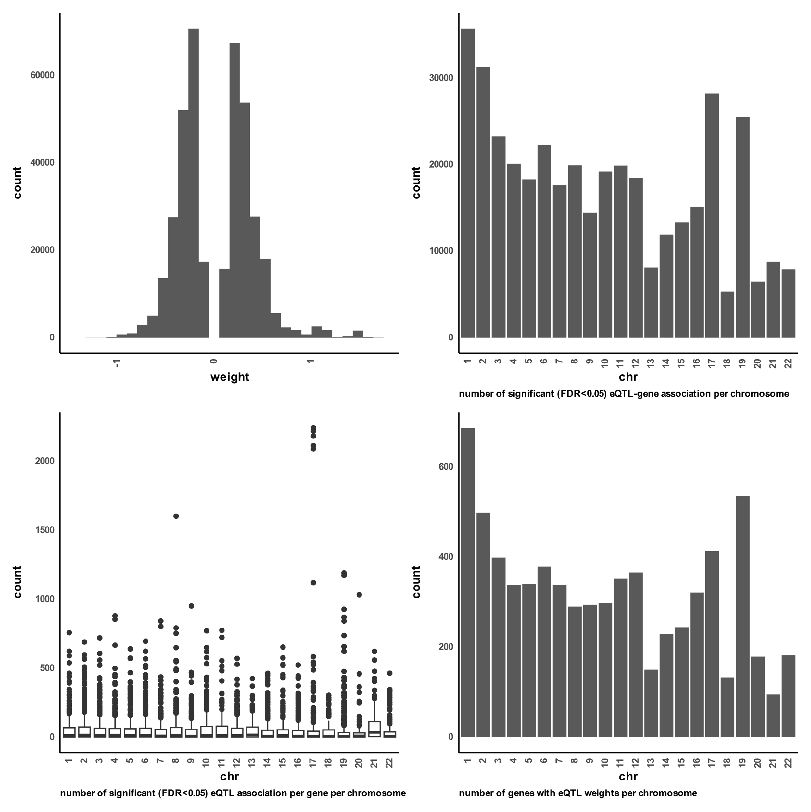

**Figure S 1 distributions of excitatory eQTL weights.**   
A) a histogram distribution of all significant (FDR < 0.05) gene-eQTL weights of all chromosomes. B) boxplot distribution of number of eQTL associations found per gene on each chromosome. C) boxplot for distribution of number of significant (FDR < 0.05) gene-eQTL associations per chromosome. D) distribution of number of unique genes found with significant (FDR < 0.05) gene-eQTL associations per chromosome.

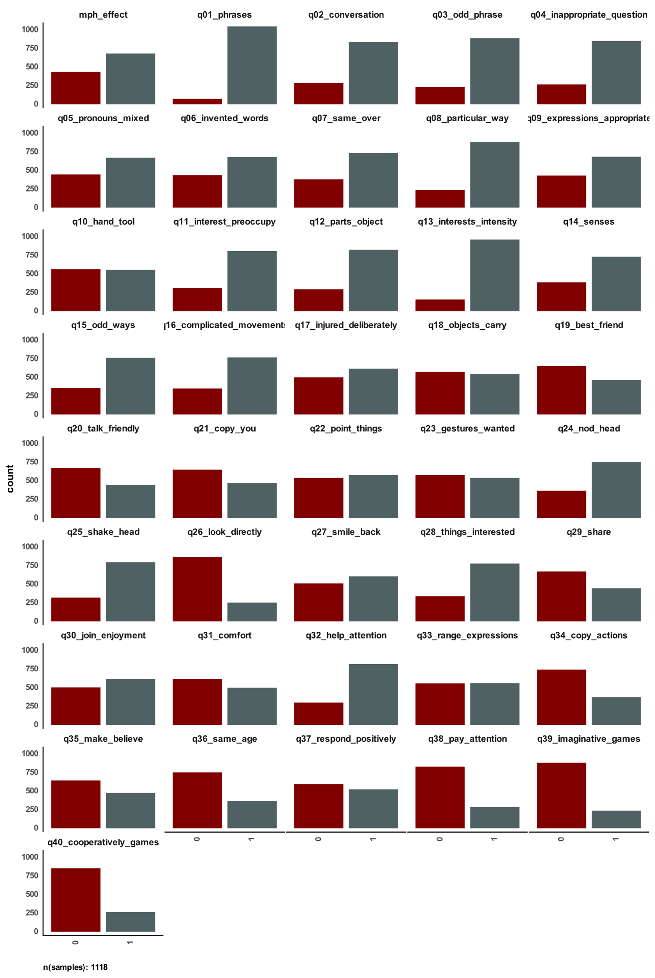

**Figure S 2 distribution of answers to social communication questionnaire in SPARK and used MPH effectiveness label.**   
The figure shows number of YES (=1) and NO (=0) answers per question in the social communication questionnaire for all samples with reported methylphenidate effectiveness.

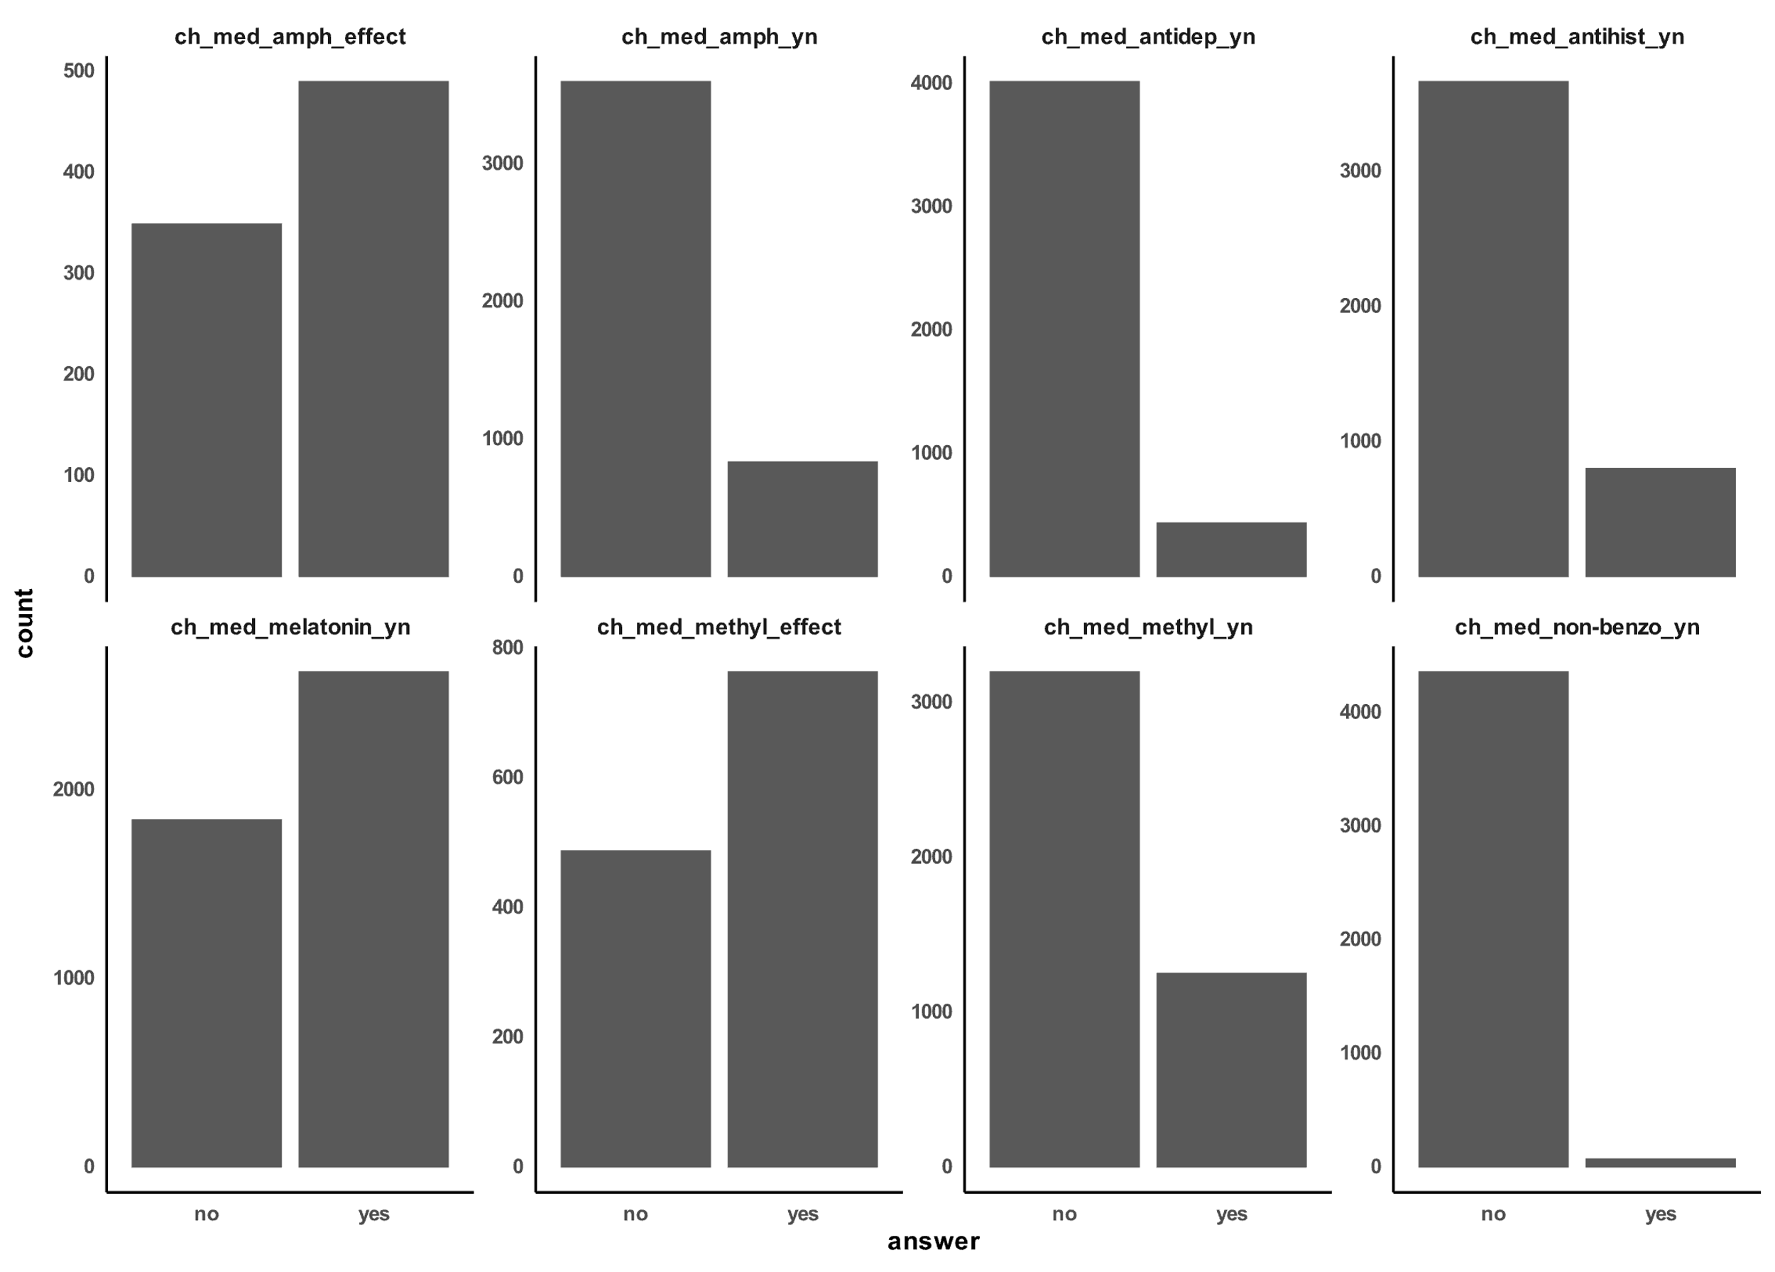

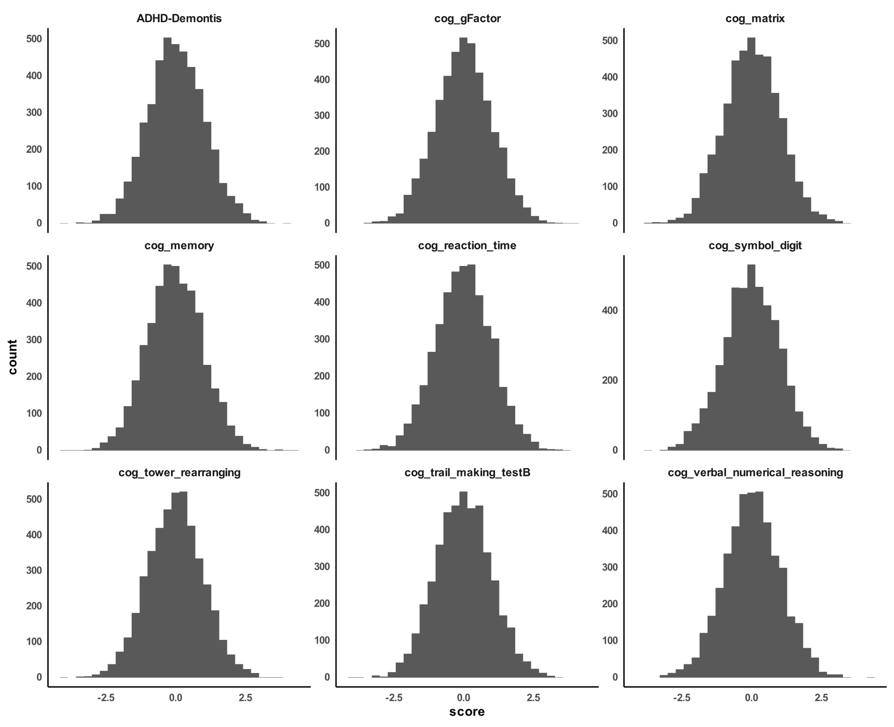

**Figure S 3 distribution of calculated polygenic scores for SPARK participants with reported methylphenidate effectiveness.**

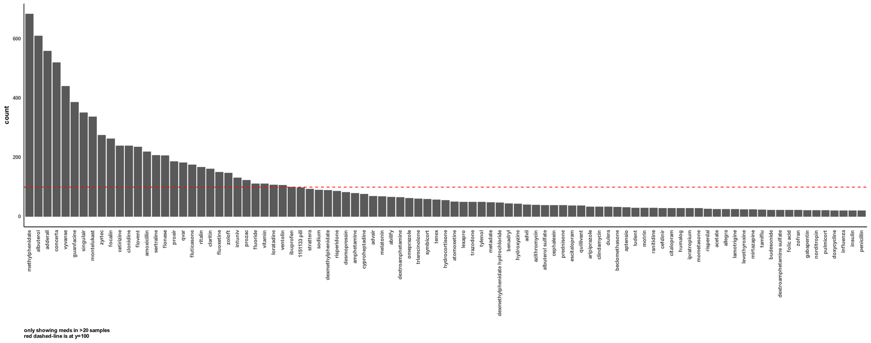

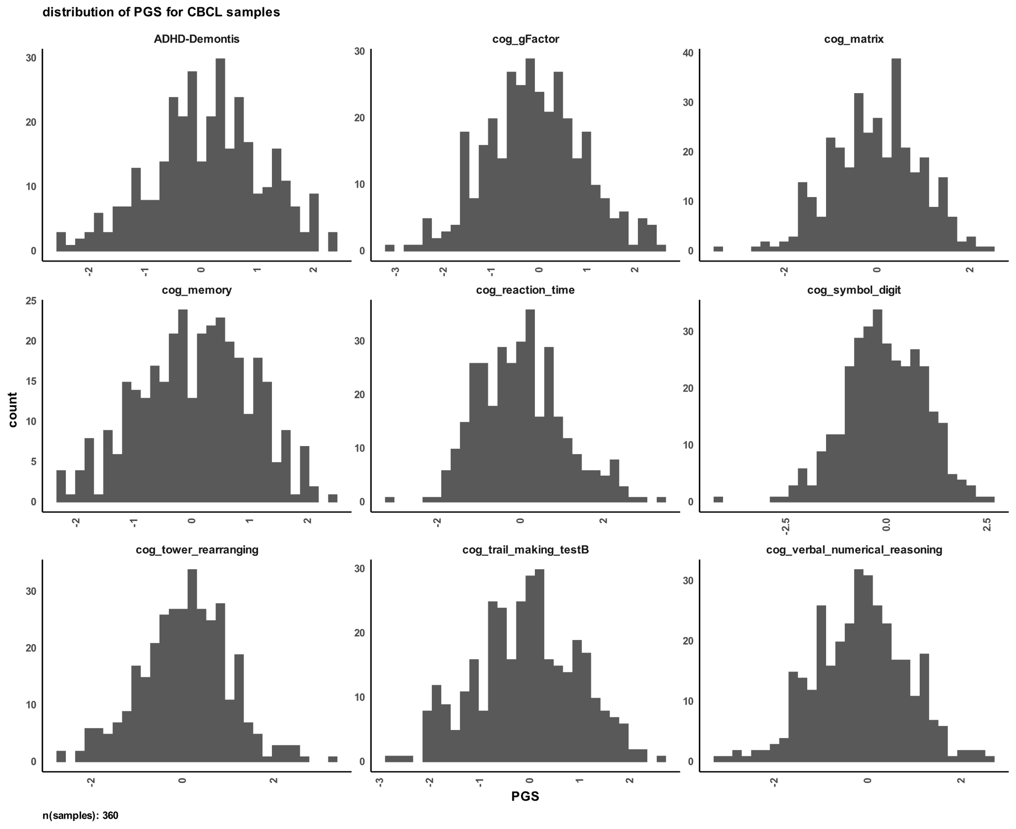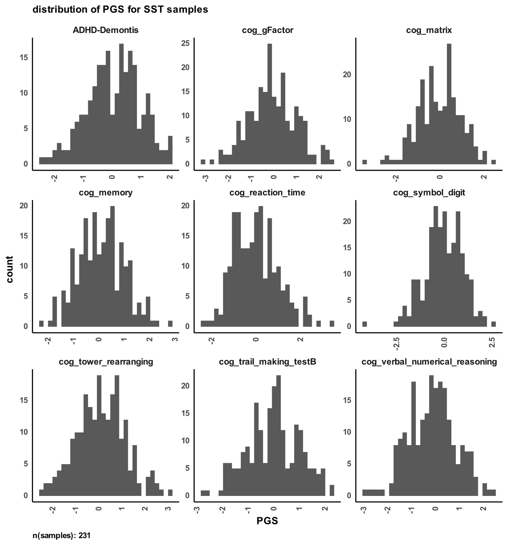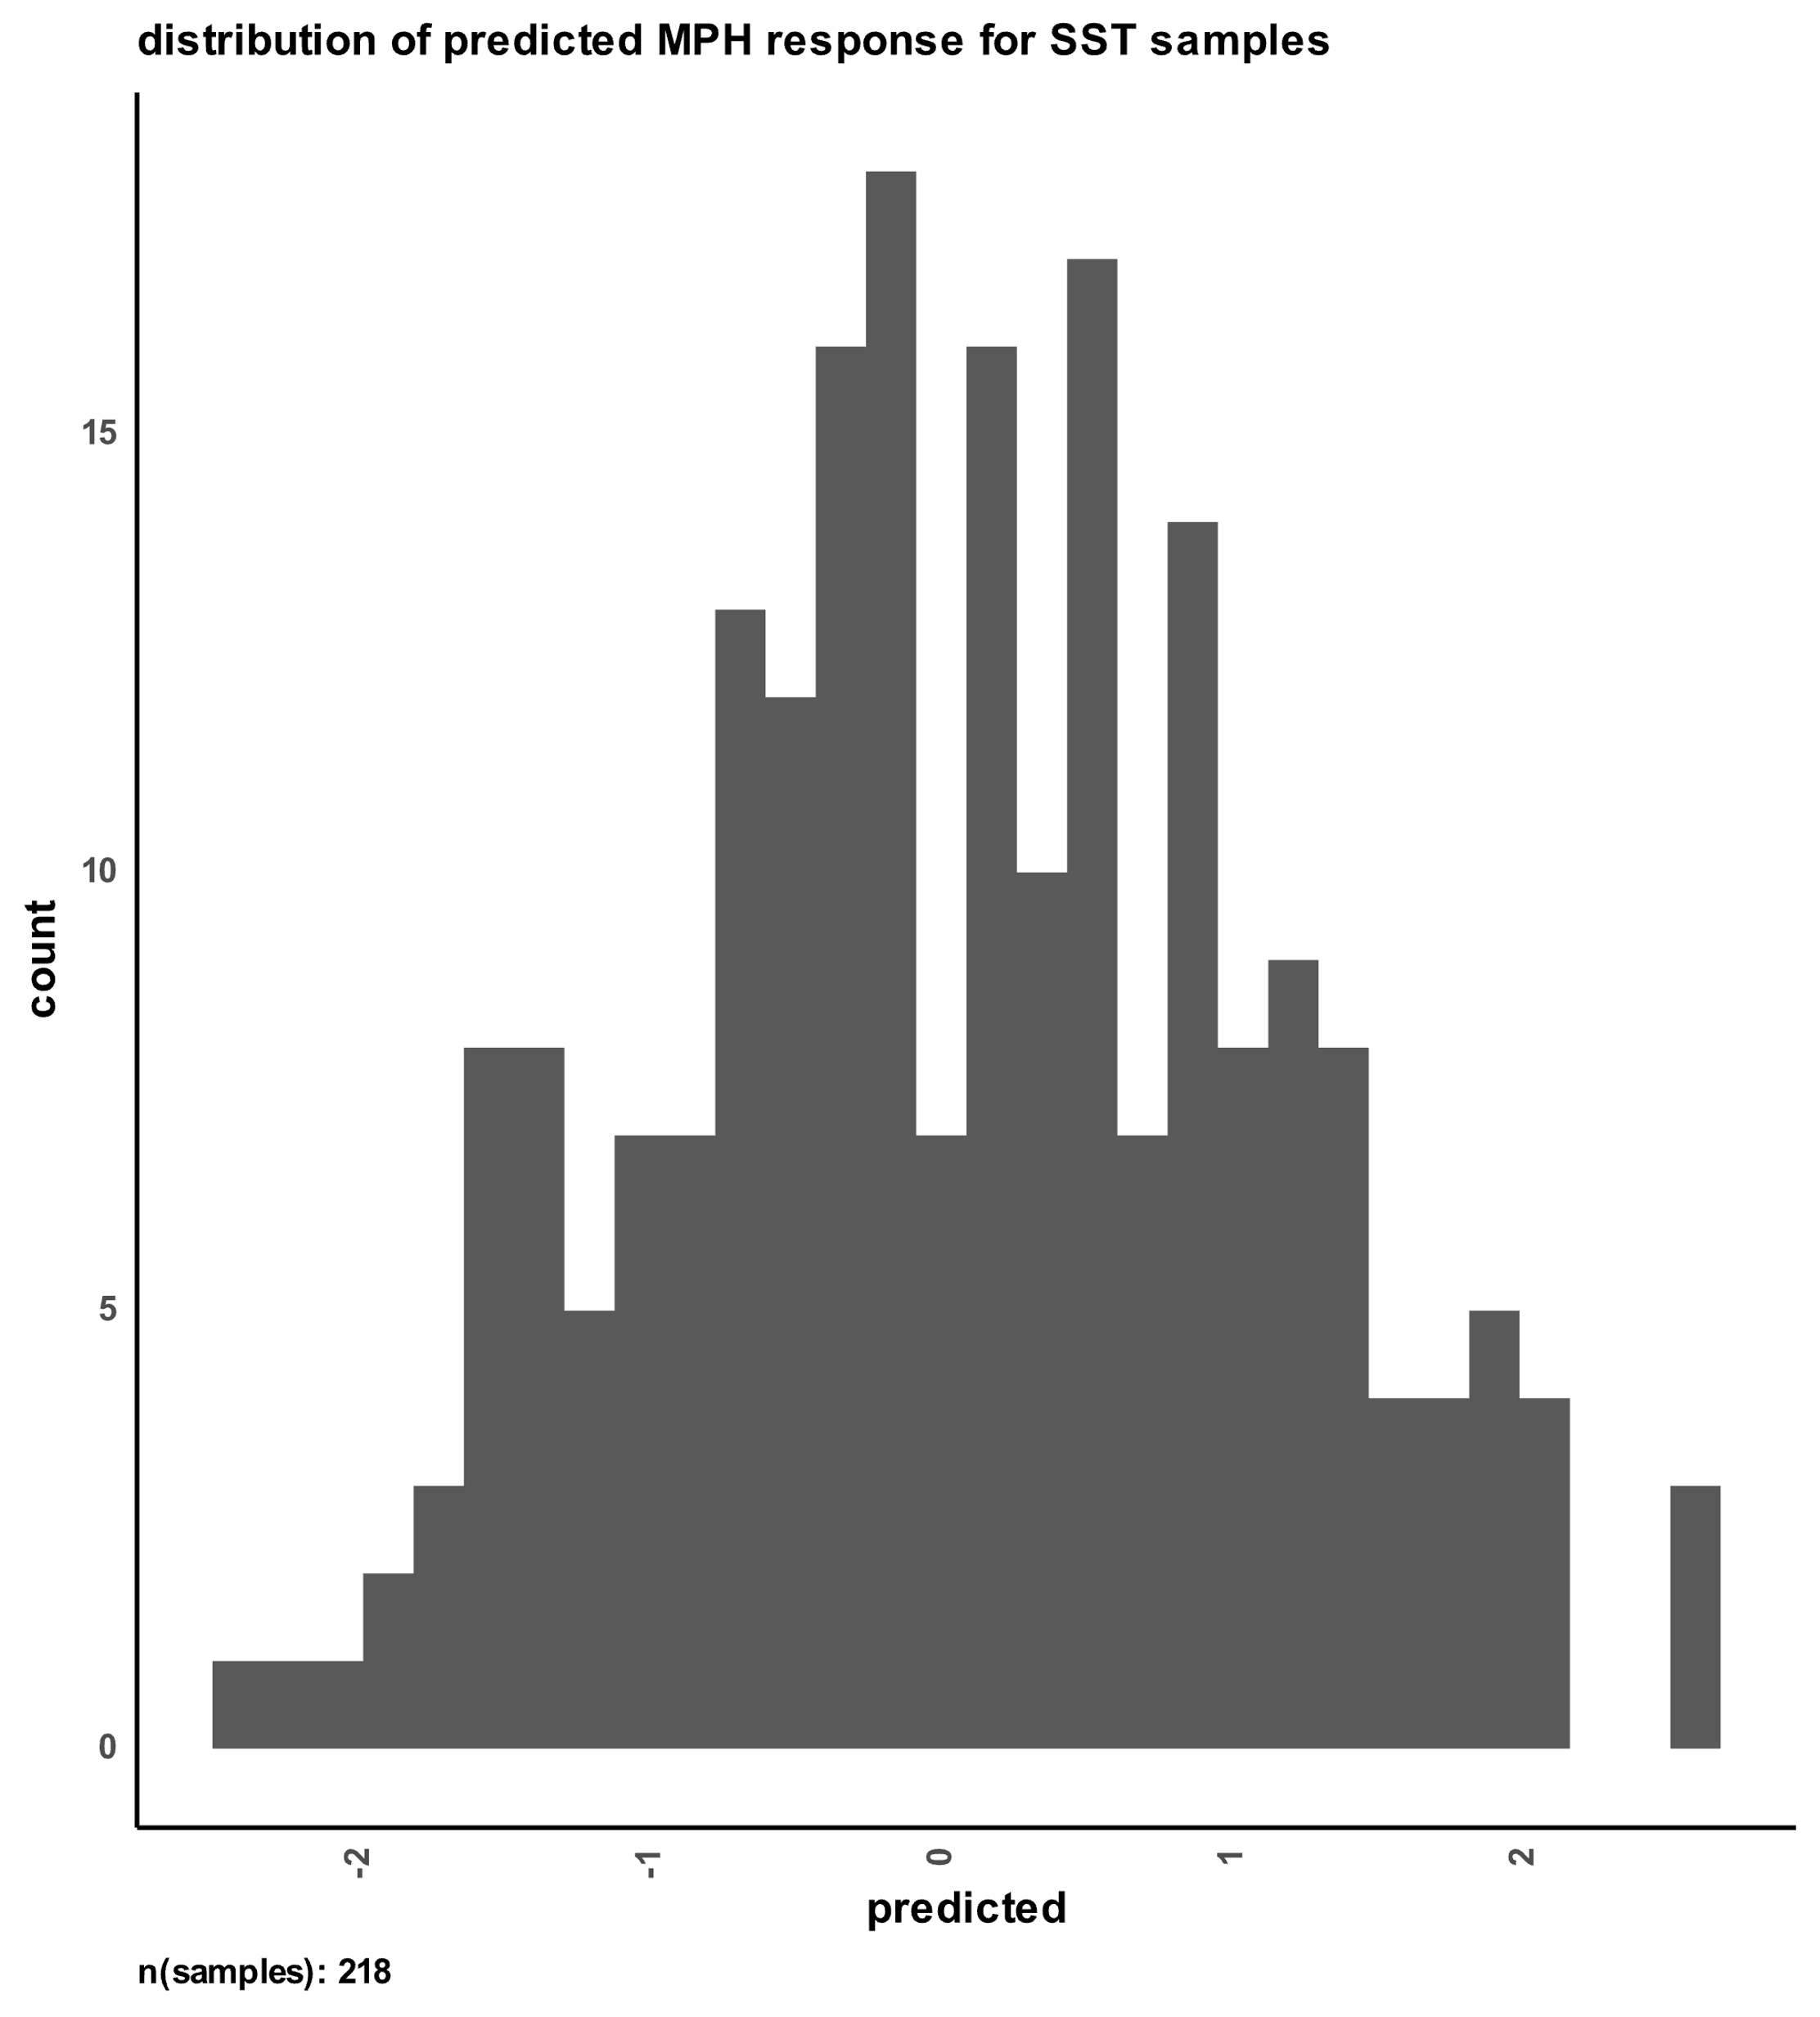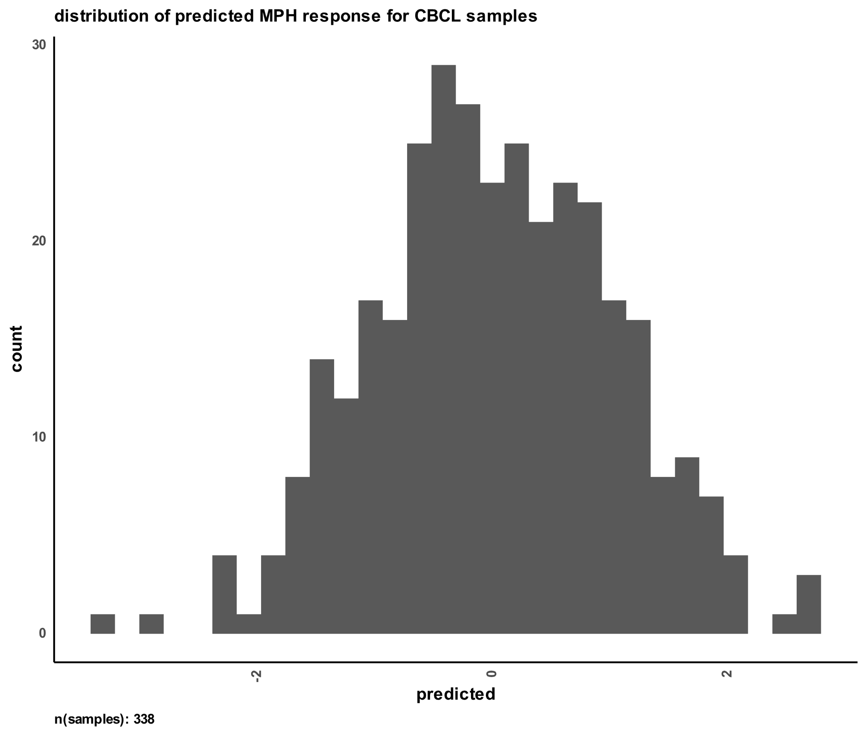

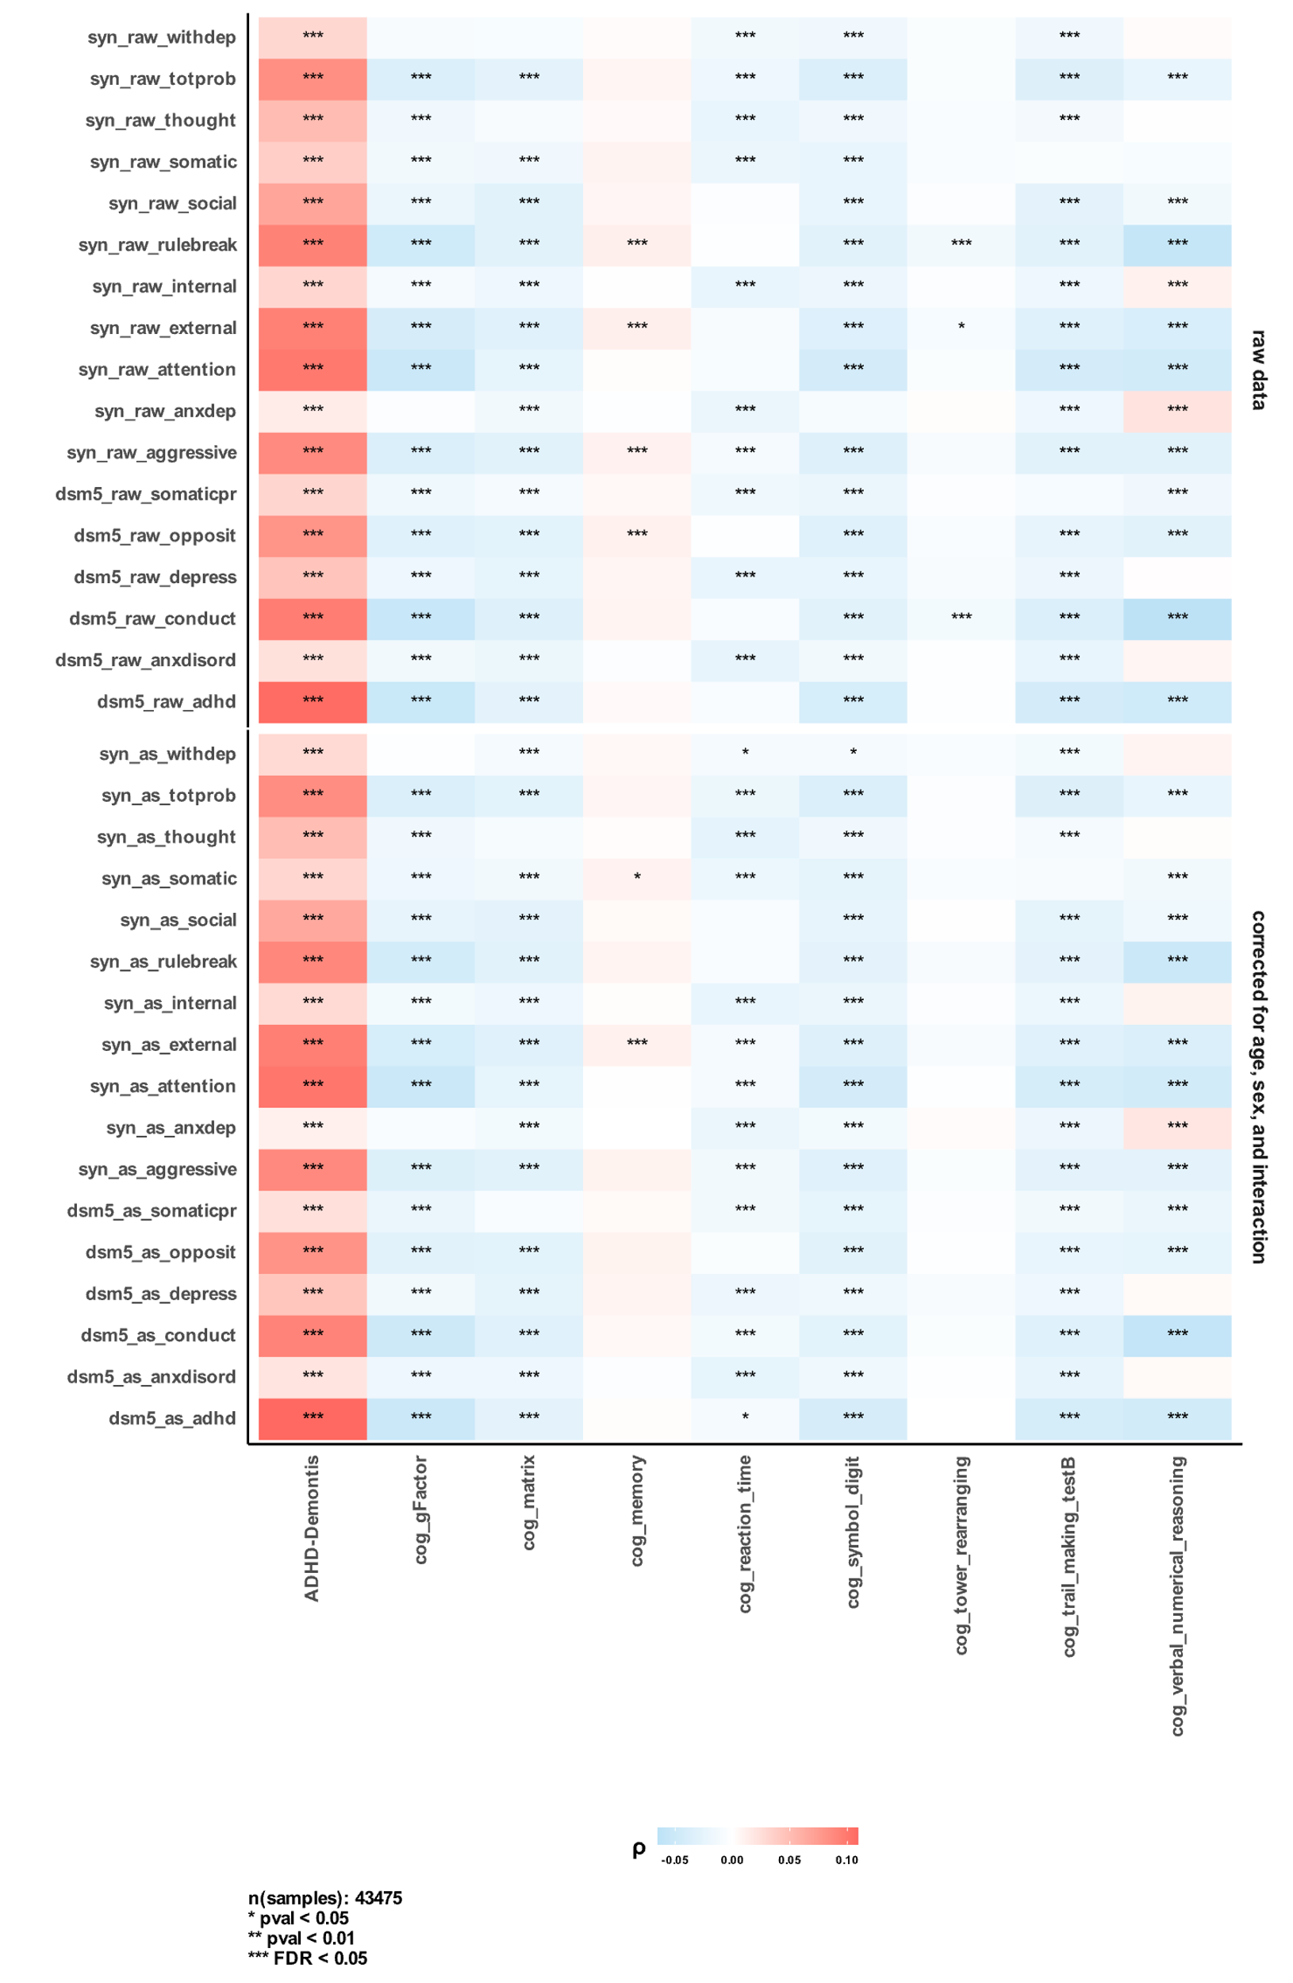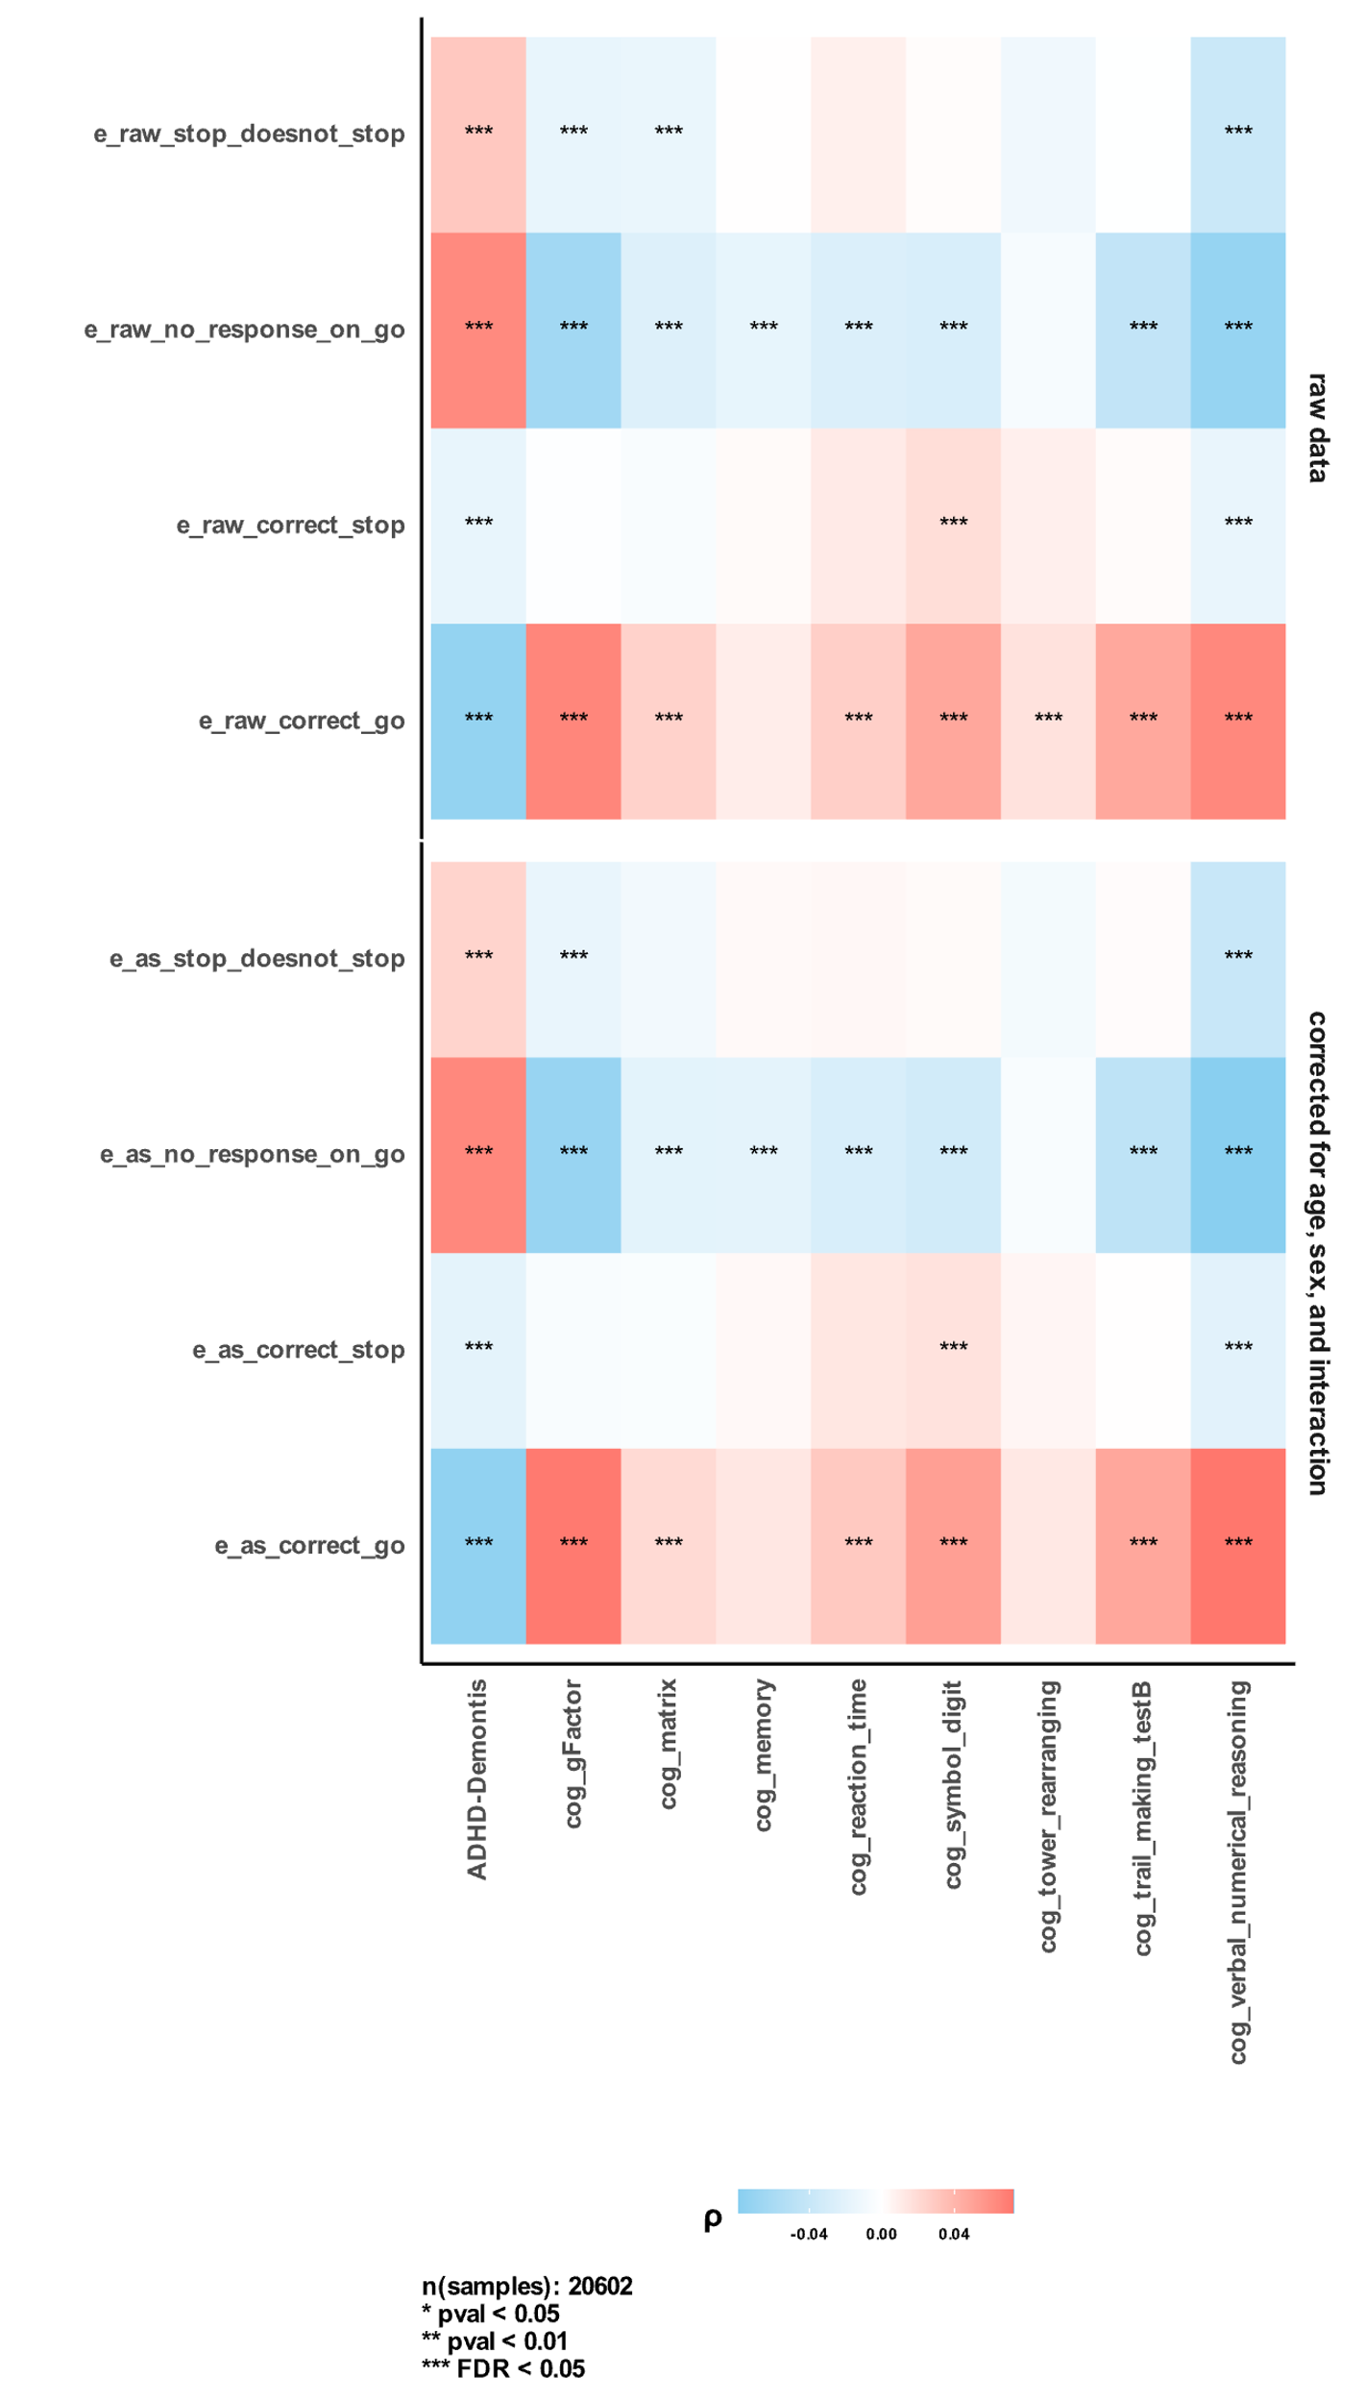

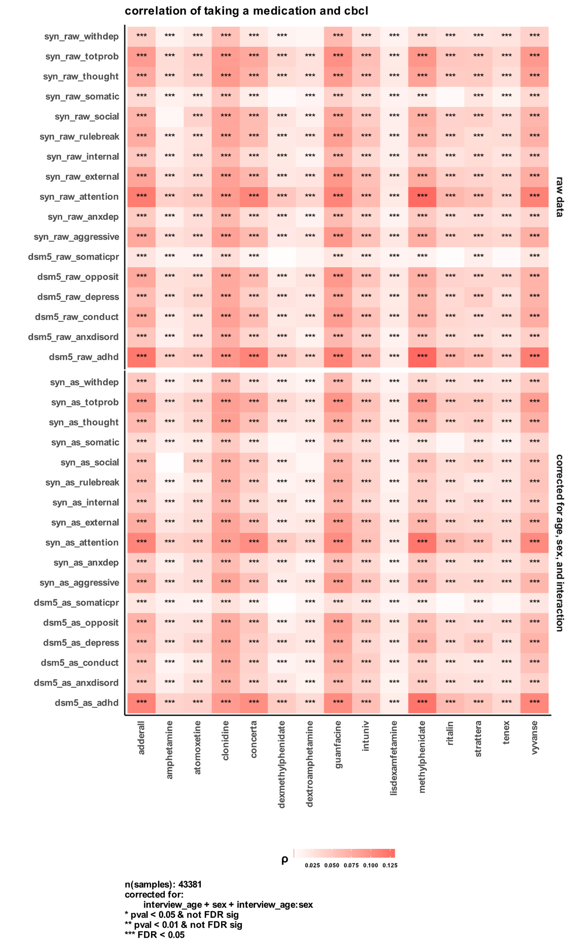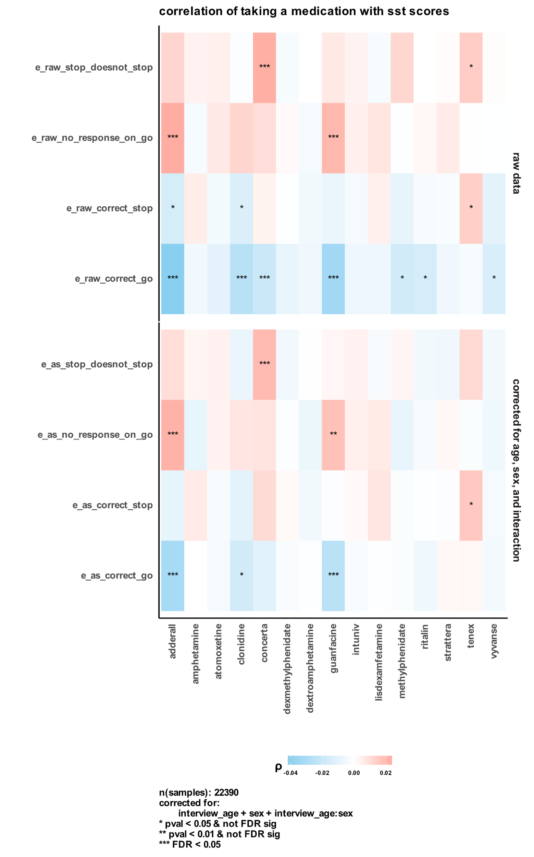

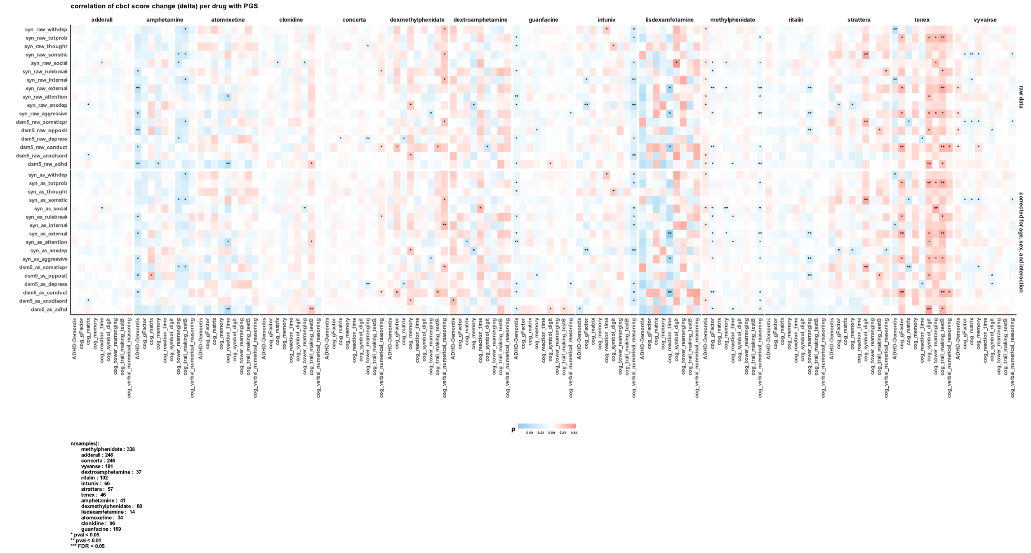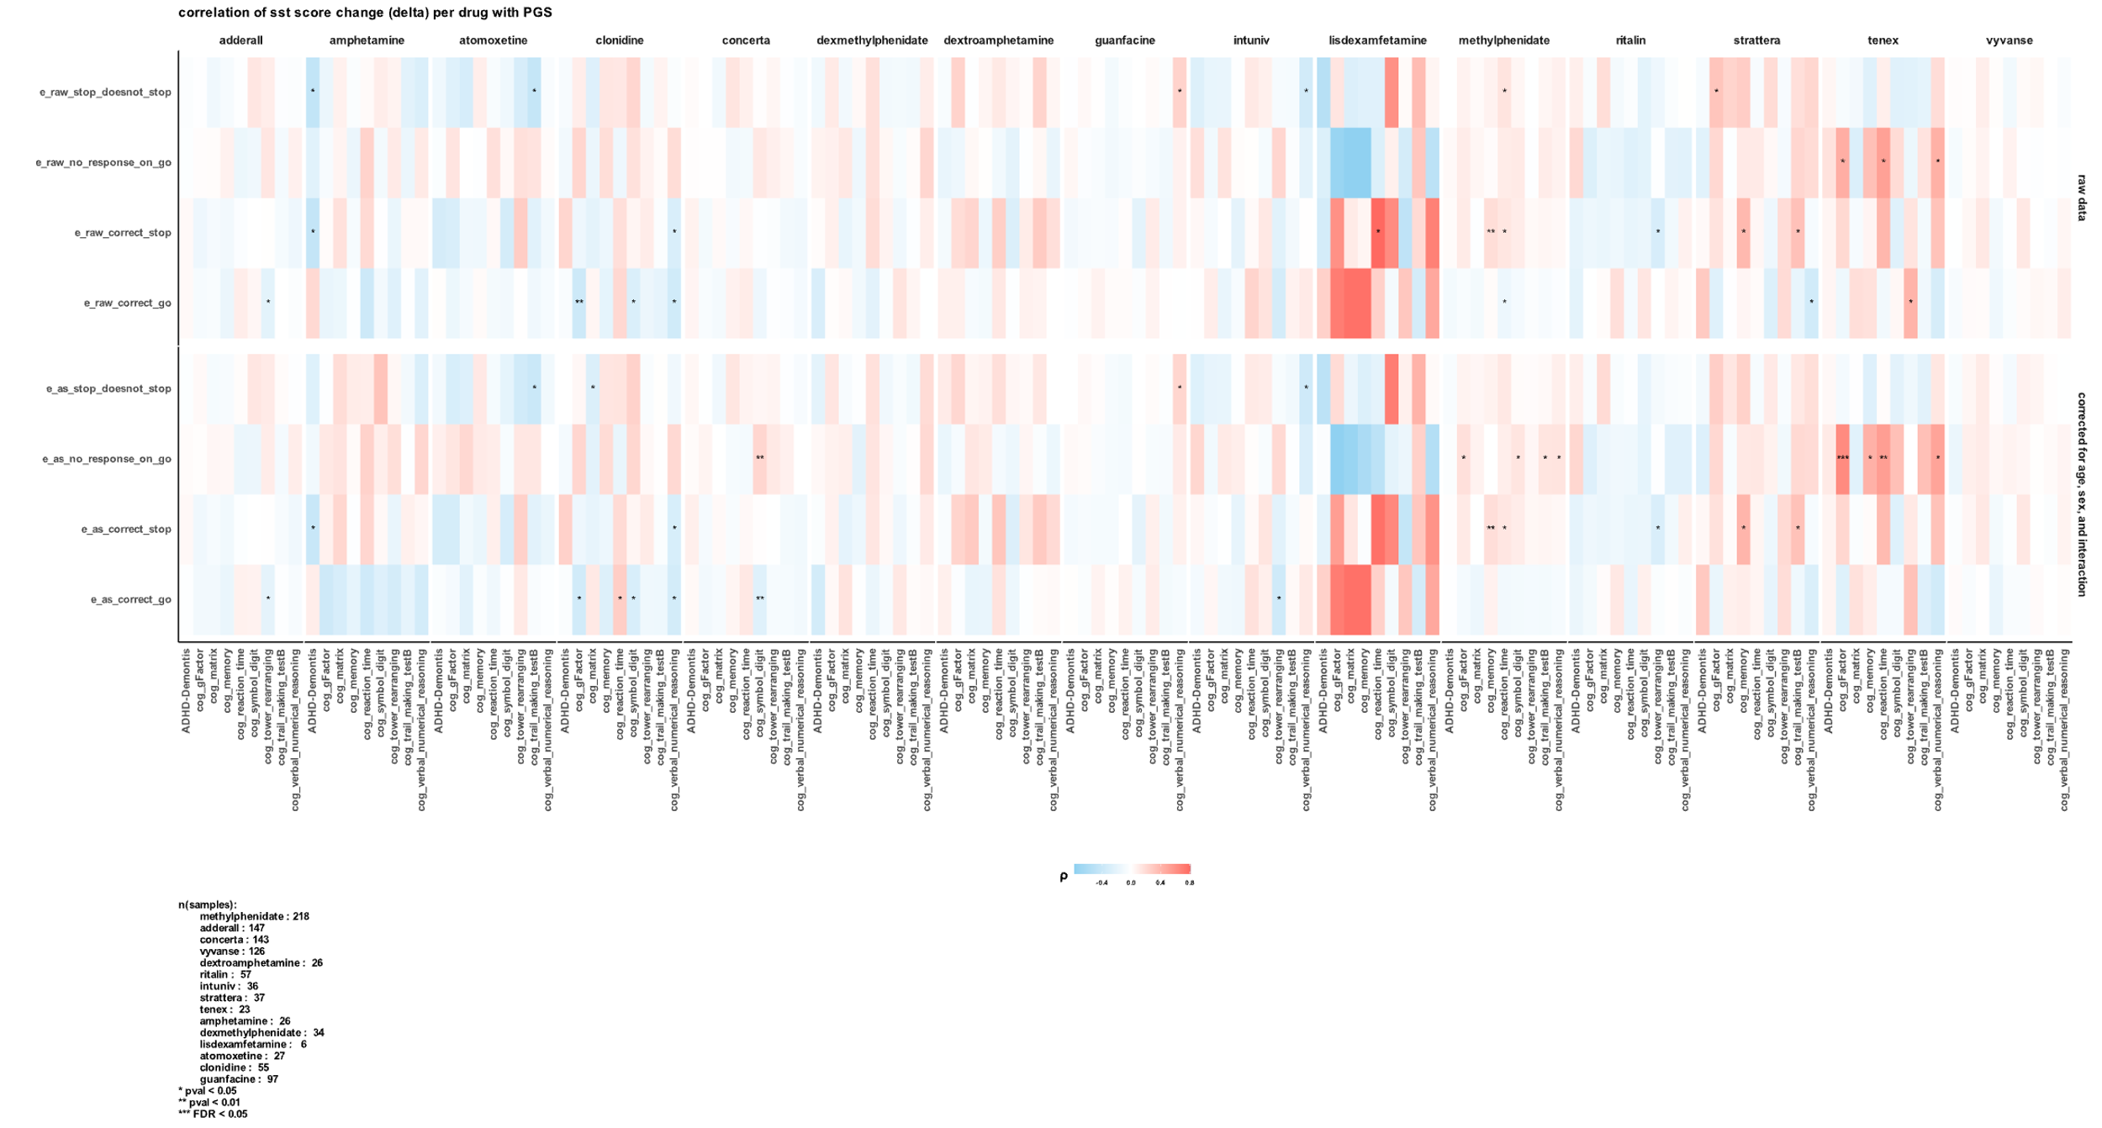

1. https://sparkforautism.org
2. https://abcdstudy.org
3. <https://www.broadinstitute.org/connectivity-map-cmap>